Table of Contents

# Ane.27.9a stock (Anchovy in ICES Division 9a). Southern component (Anchovy in ICES Subdivision 9a South): Assessment Using Age Composition data.

Autores…

## Assessment model

The assessment of the **southern anchovy southern component** was performed in Stock Synthesis software, version 3.30.22 (**insertar cita Methot et al., 2023**) under the MAC platform. SS is a generalized age and/or length-based model that is very flexible with regard to the types of data that may be included, the functional forms that are used for various biological processes, the level of complexity and number of parameters that may be estimated. The model is coded in C++ with parameter estimation enabled by automatic diferentitation (www.admb-project.org) and available at the NOAA Fisheries integrated toolbox: <https://noaa-fisheries-integrated-toolbox.github.io/SS3>. A description and discussion of the model can be found in **incluir cita Methot and Wetzel (2013)**.

The stock assessment has been performed for the period 1989-2023 with **the method and settings agreed during the bechmark (ICES, 2024)**. The **southern anchovy southern component** assessment model is a one area, annual with data in quarters, age-based model where the population is comprised of 3+ age-classes (with age 3 representing a plus group) with sexes combined (male and females are modelled together).

### Data

Input data include total catch (in biomass), length composition of the catch (in numbers), abundance (in biomass) and length composition from an annual *PELAGO*, *ECOCADIZ*, *ECOCADIZ-RECLUTAS* surveys, and spawning-stock biomass (SSB) from triennial DEPM *BOCADEVA* survey. The **Figure x** provides a visual representation of the input data used in the stock assessment model, categorized into three main types: catches, abundance indices, and age compositions. These data are displayed over time (years) and are represented by circles, with the size of each circle reflecting the magnitude of the data.

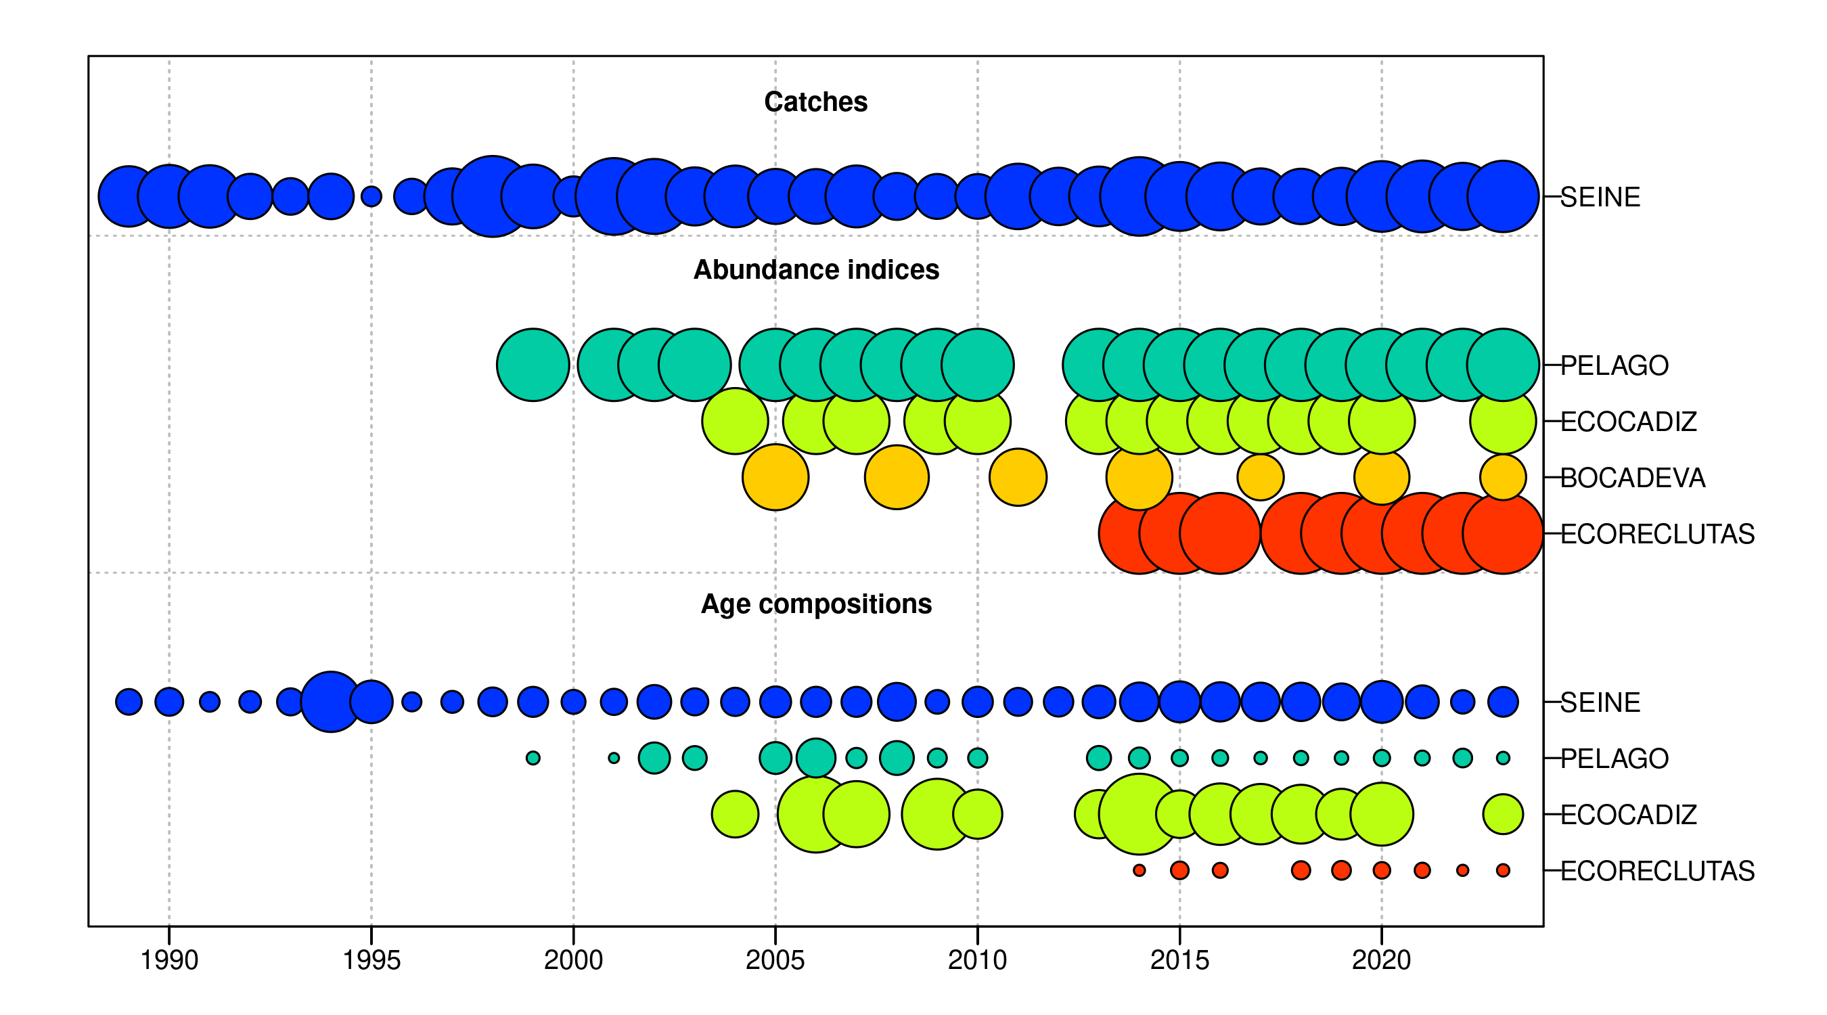 Figure .: Ane.27.9a stock. summarises data presence by year, where circle area is relative within a data type. Circles are proportional to total catch for catches, to precision for indices and to total sample size for compositions.

#### Catches

Over the past few decades, long-term trends in fish catches have exhibited variability, characterized by peaks in certain periods and phases of stabilization. In the 1990s, catches initially increased, declined in the mid-decade, and recovered towards the end of the period. In the early 2000s, catches reached their highest point, particularly around the year 2000, followed by a gradual decline leading to stabilization throughout the remainder of the decade. Between 2010 and 2019, catches remained stable, with minor fluctuations and an increase towards the end of this period. In the 2020s, catches increased again, reaching levels comparable to those observed in the early 2000s (**Figure and Table**).

The quarterly pattern of catches shows that the second (Q2) and third quarters (Q3) consistently record the highest catch volumes over the years, indicating these periods as the most active. The first quarter (Q1) also contributes to the annual totals, although at a lower level compared to Q2 and Q3. The fourth quarter (Q4) consistently records the lowest catch volumes, reflecting a period of reduced activity (**Figure and Table**).

 Figure .: Ane.27.9a stock. Quarterly Catch.

Table .: Ane.27.9a stock. Quarterly and Annual Catch Totals.

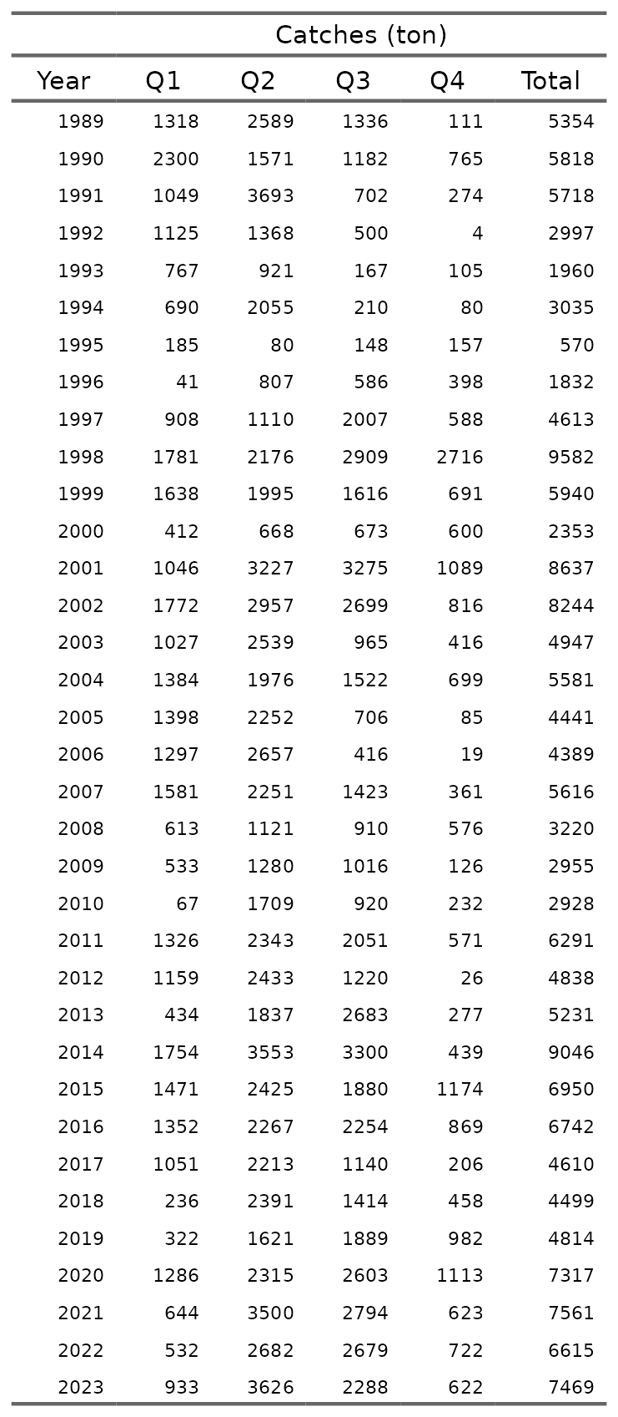

#### Abundances indices

The abundance indices *PELAGO*, *ECOCADIZ*, *BOCADEVA*, and *ECORECLUTAS* exhibit interannual variability over time. *PELAGO*, with data from 1999 to 2023, shows fluctuations with a peak in 2016 at 65,345 tons, followed by a decline, but with a slight recovery in 2023 to 26,786 tons. *ECOCADIZ*, covering the period from 2004 to 2023, reaches its maximum in 2019 at 57,700 tons, followed by a significant decrease to 9,714 tons in 2023. *BOCADEVA*, with data from 2005 to 2023, shows a steady increase to its peak in 2020 at 81,466 tons, followed by a reduction to 15,138 tons in 2023. *ECORECLUTAS*, recorded from 2014 to 2023, shows a sustained increase until 2019 at 48,398 tons, followed by a decrease to 8,300 tons in 2023. These patterns reflect changes in the abundance of anchovy in the Gulf of Cádiz over time, with periods of increase followed by declines in the later years of each series (**Figure and Table**).

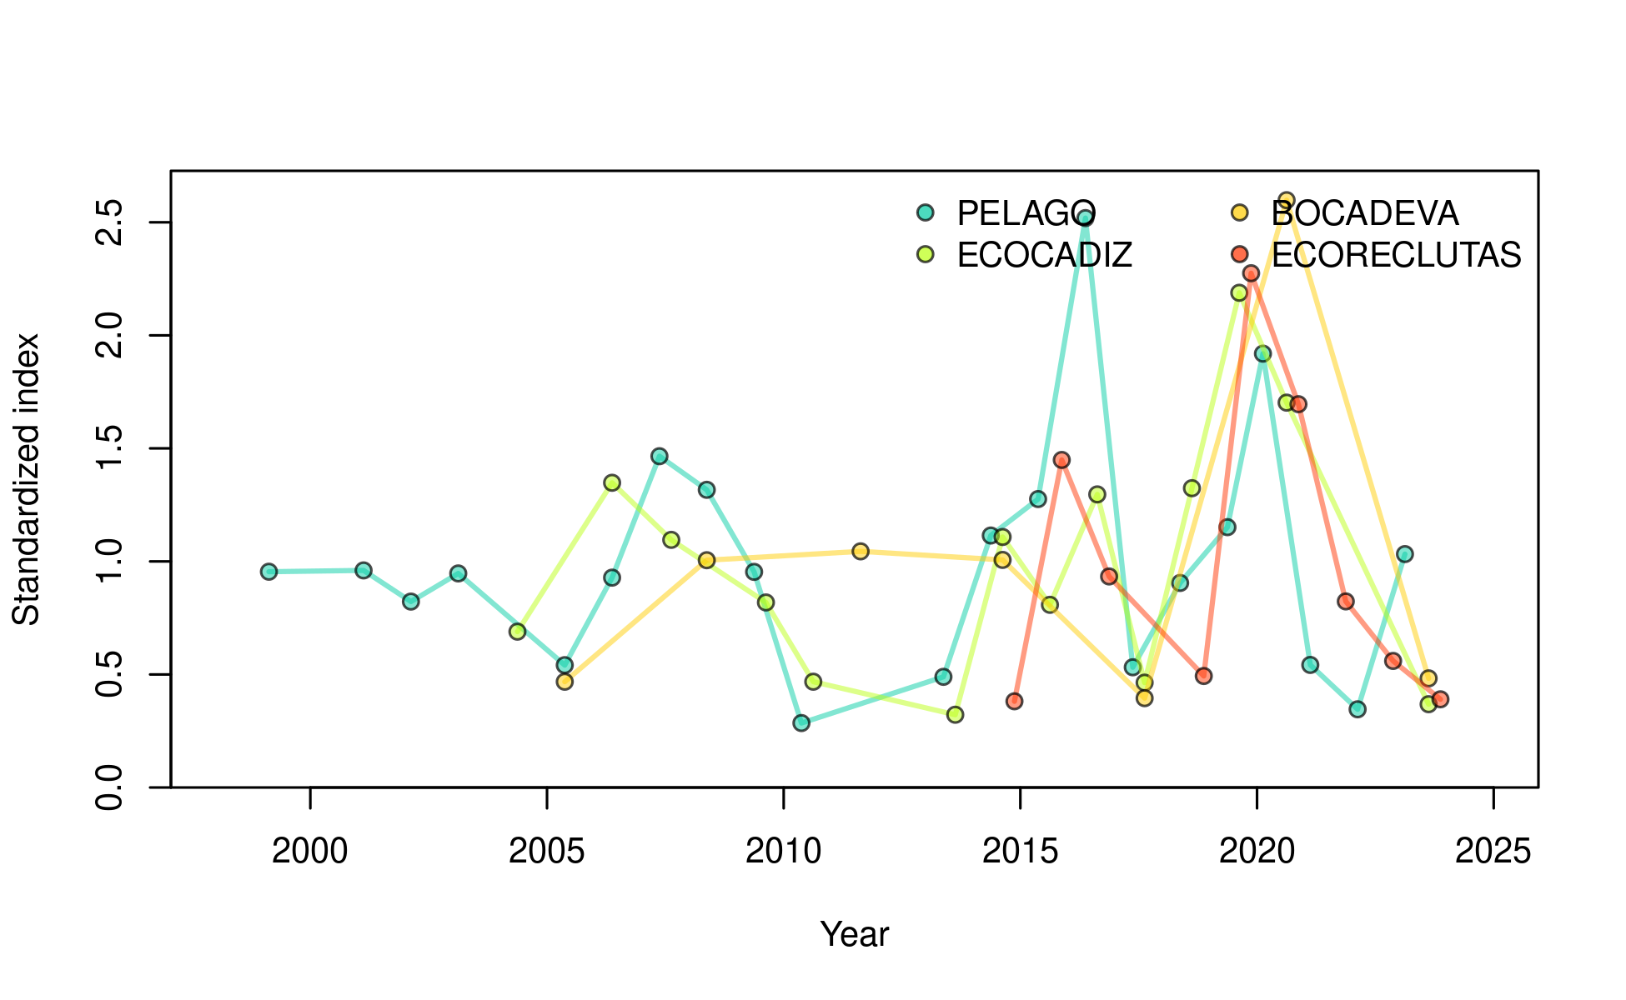

Figure .: Ane.27.9a stock. Time series of biomass indices for the Gulf of Cádiz anchovy stock, represented by the *PELAGO*, *ECOCADIZ*, *BOCADEVA*, and *ECORECLUTAS* indices.

Table .: Ane.27.9a stock. Acoustic biomass (ton) by surveys *PELAGO*, *ECOCADIZ*, *BOCADEVA*, and *ECORECLUTAS*.

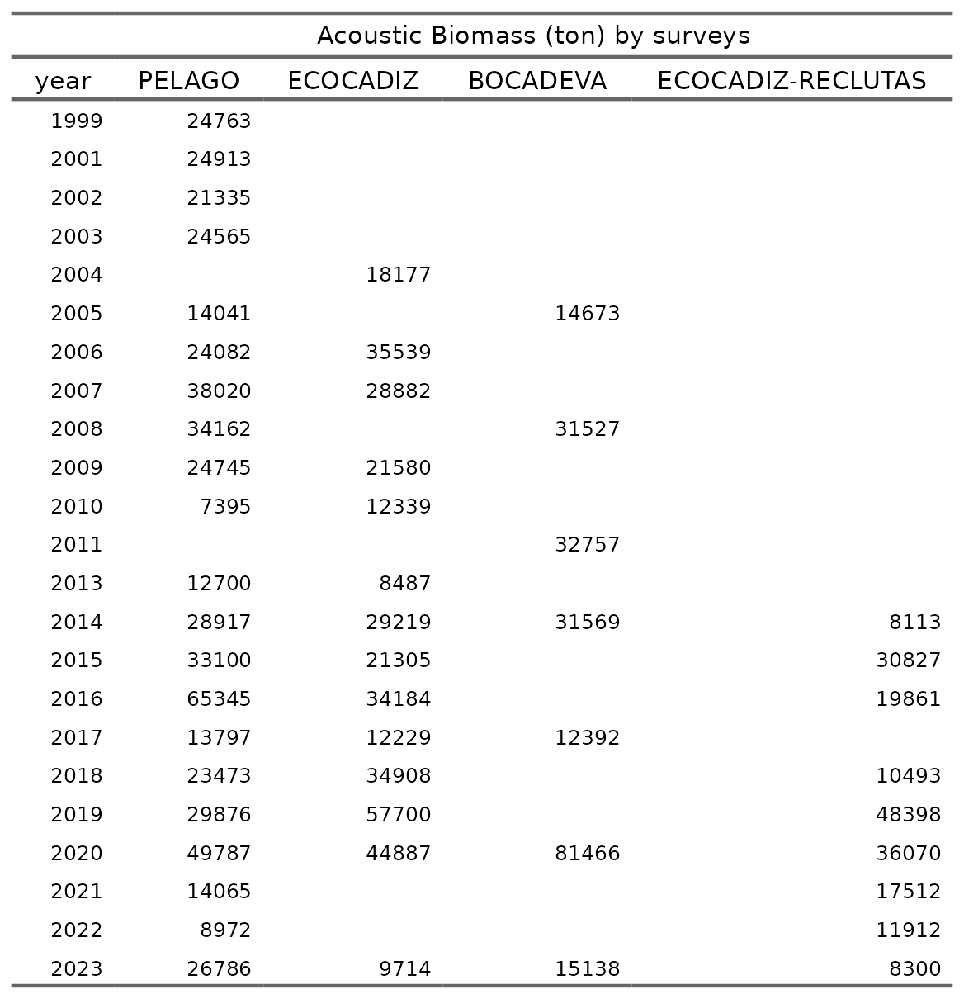

#### Age composition

##### Commercial fleet

In the stock assessment model, the age proportion of the commercial fleet (*SEINE*) by quarter and year (1989 to 2023) is used. The historical trend indicates that age 0 is not recorded in Q1 and Q2, but its proportion increases in Q3 and Q4 in more recent years. Age 1 predominates in Q1 and Q2, maintaining a constant proportion over time. In Q3 and Q4, the proportion of age 1 individuals decreases as the proportion of age 0 increases. Ages 2 and 3 exhibit lower and variable proportions across all quarters over the years, without a defined pattern of change (**Figure**).

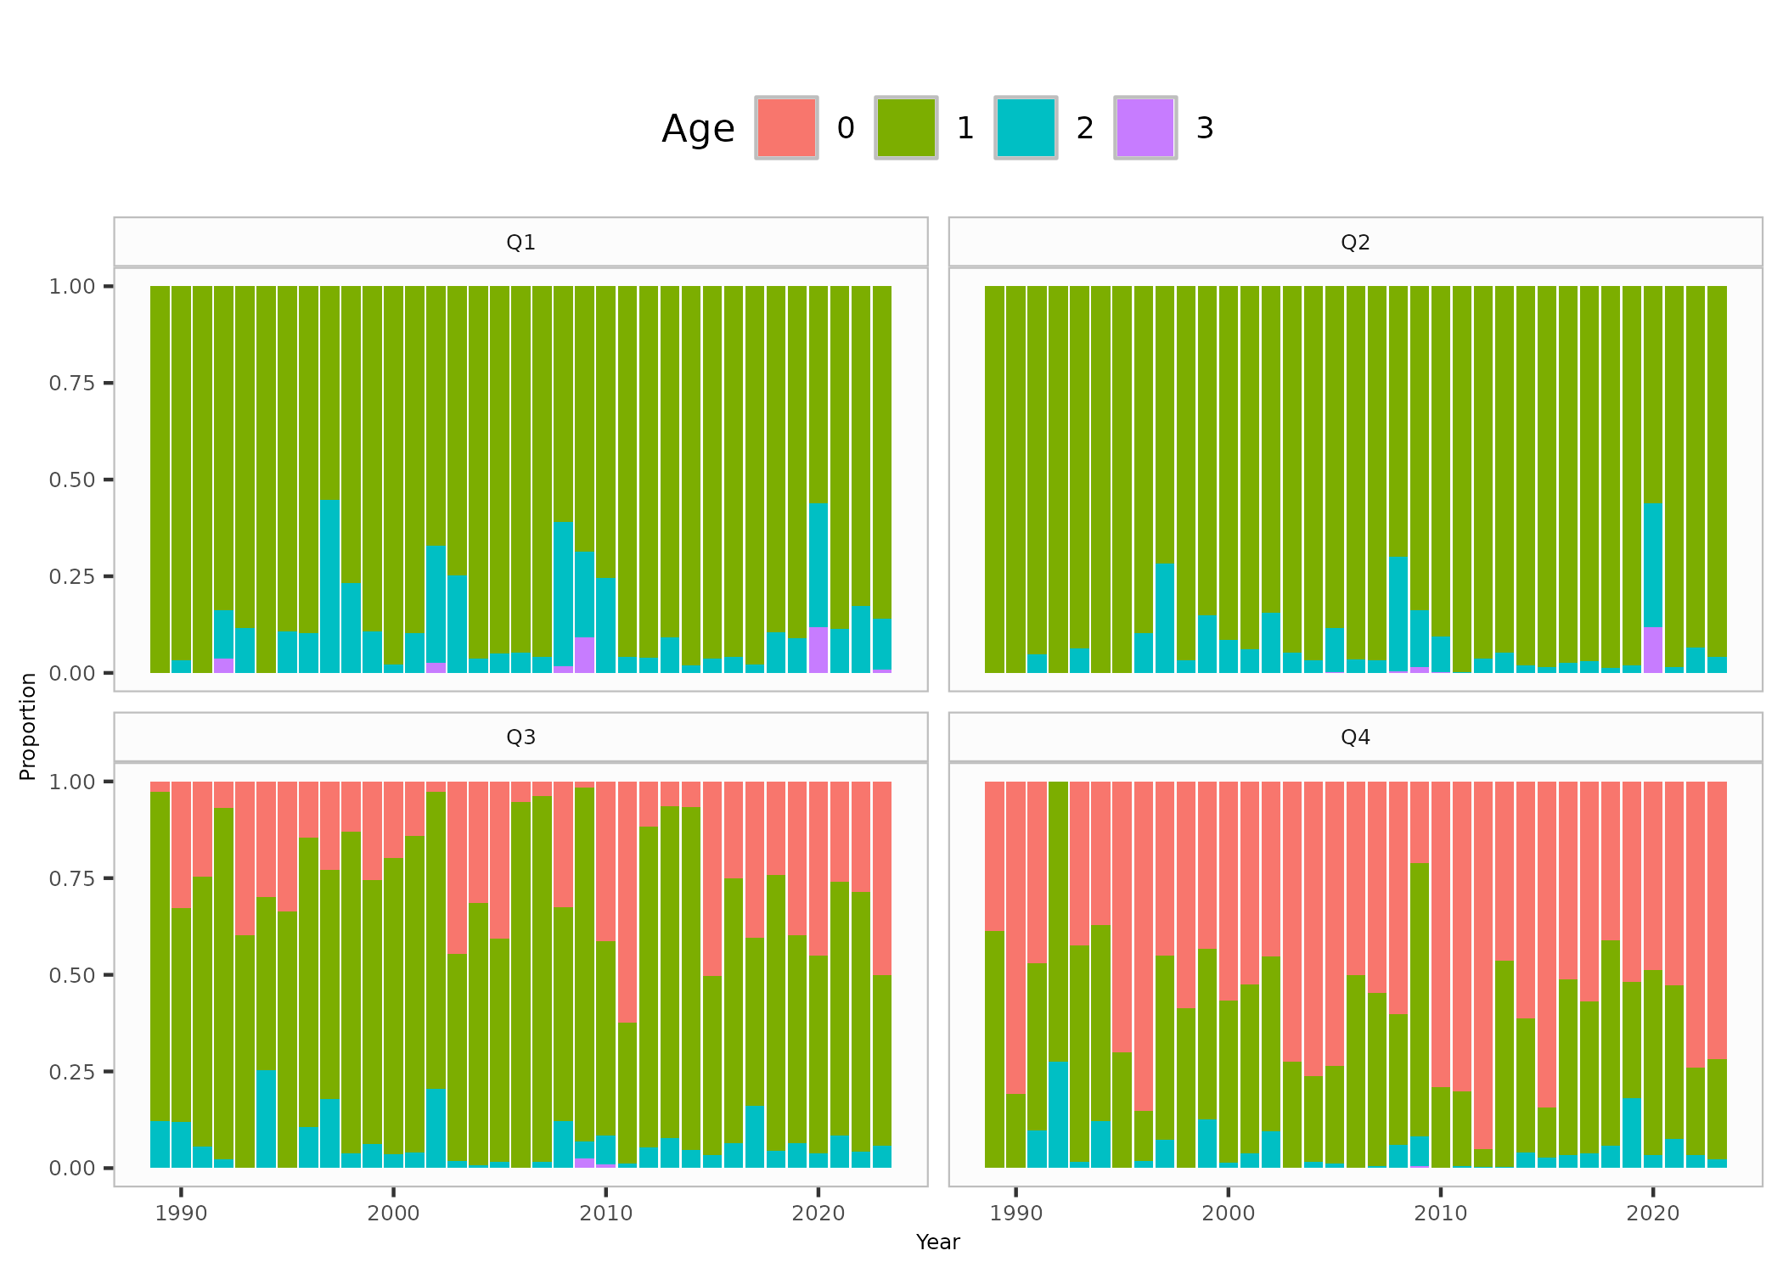

Figure .: Ane.27.9a stock. Age proportion of the commercial fleet (*SEINE*) by quarter and year (1989 to 2023) .

##### Surveys

The stock assessment model utilizes age proportions from different surveys (*PELAGO*, *ECOCADIZ*, and *ECOCADIZ-RECLUTAS*) by year. The figure shows that in the *PELAGO* survey, conducted in the second quarter (Q2), age 1 represents the highest proportion over time, with a presence of ages 2 and 3, and no records of age 0 individuals. The *ECOCADIZ* survey, primarily conducted in the third quarter (Q3), shows a predominance of age 1, with an increase in the proportion of age 0 from 2010 onward; in 2004 and 2006, when the survey was conducted in the second quarter (Q2), no age 0 individuals were recorded. The *ECOCADIZ-RECLUTAS* survey, conducted since 2014 in October (fourth quarter, Q4), shows a higher proportion of age 0, followed by age 1, with lower representation of ages 2 and 3 (**Figure**).

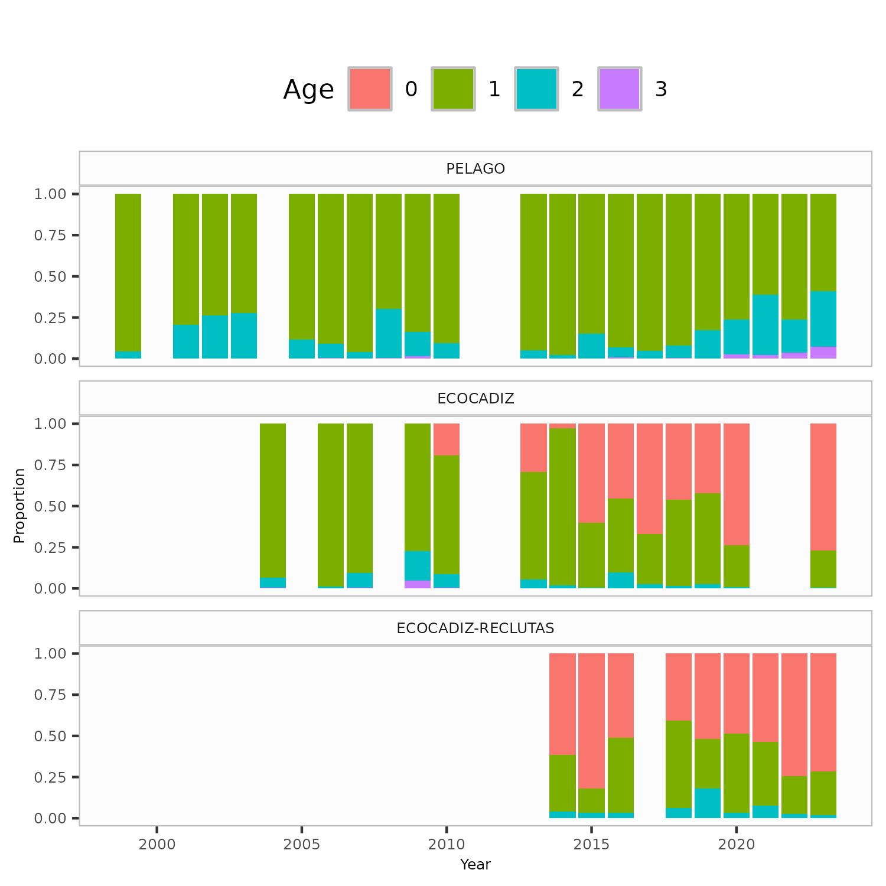 Figure .: Ane.27.9a stock. Age proportion by surveys (*PELAGO*, *ECOCADIZ*, and *ECOCADIZ-RECLUTAS*).

### Data weighting

#### survey date, coeficient variation (CV) and samples size (nm)

A standar error of **0.10** was assumed for all years of catches and **xx** for the *PELAGO*, *ECOCADIZ*, *ECOCADIZ-RECLUTAS* surveys, and spawning-stock biomass (SSB) from triennial DEPM *BOCADEVA* survey, reflecting the accurate sampled catches and the CV level of the surveys. A standard error of **xx** is assumed for all years for the DEPM index based on the uncertainty of the SSB estimates.

The Francis method T.A.xxx was selected for length data weighting in catches and surveys data. The initial population is calculated by estimating an initial equilibrium population modified by age composition data in the first year of the assessment (**Methot and Wetzel, 2013**). The model starts in 1989 and the equilibrium population age structure was assumed to be in an exploited state with an initial . Variance estimates for all estimated parameters are calculated from the Hessian matrix. Minimisation of the likelihood is implemented in phases using standard ADMB process. The phases in which estimation will begin for each parameter is shown in the control file available in the TAF repository for this stock . The R packages r4ss version 1.49.2 (**Taylor et al., 2021**) and ss3diags version 1.10.2 (**Carvalho et al., 2021**) were used to process and view model outputs. All analyses were conduction in R version 4.2.2

Table .: Ane.27.9a stock. coefficient variation and sample size by surveys *PELAGO*, *ECOCADIZ*, *BOCADEVA*, and *ECORECLUTAS*.

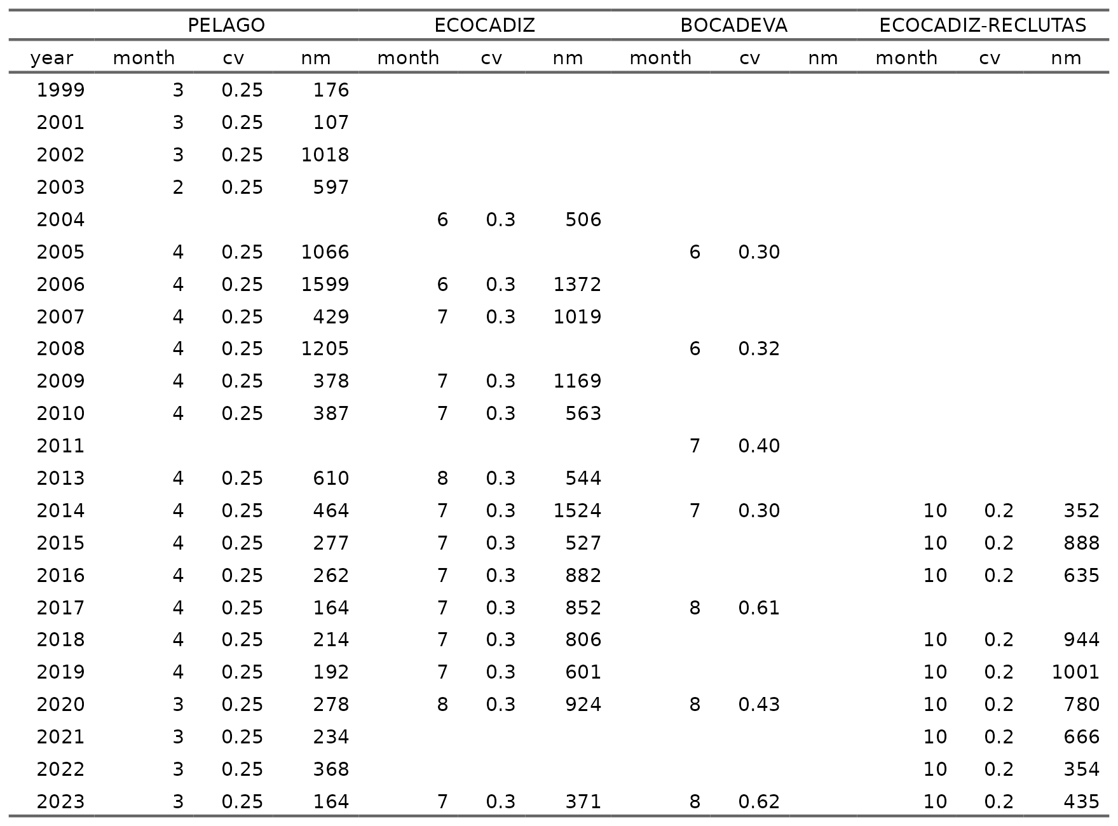

### Model setting

#### Biology

* *Natural mortality*: **Table x** presents the age-specific natural mortality input values at the beginning of the year, which were derived from external data sources. For further details, refer to the working document by **Rincón et al. (yearXXX)**.
* *Growth*: Growth is not modelled explicitly.
* *Maturity*: **Table x** presents the age-specific maturity input values at the beginning of the year were estimated from external data sources. For further details, refer to the working document by **Ramos et al. (yearXXX)**.
* *Weigth at age*: **Figure x** presents the age-specific weight-at-age input values at the beginning of the year were estimated from external data sources. For further details, refer to the working document by **XXX et al. (yearXXX)**.

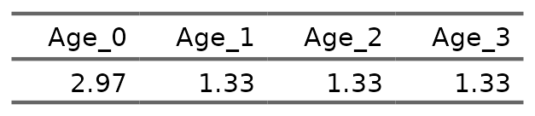

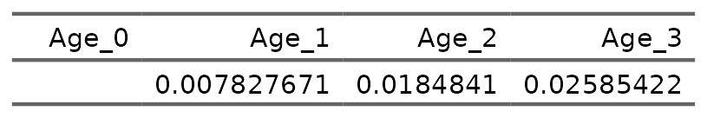

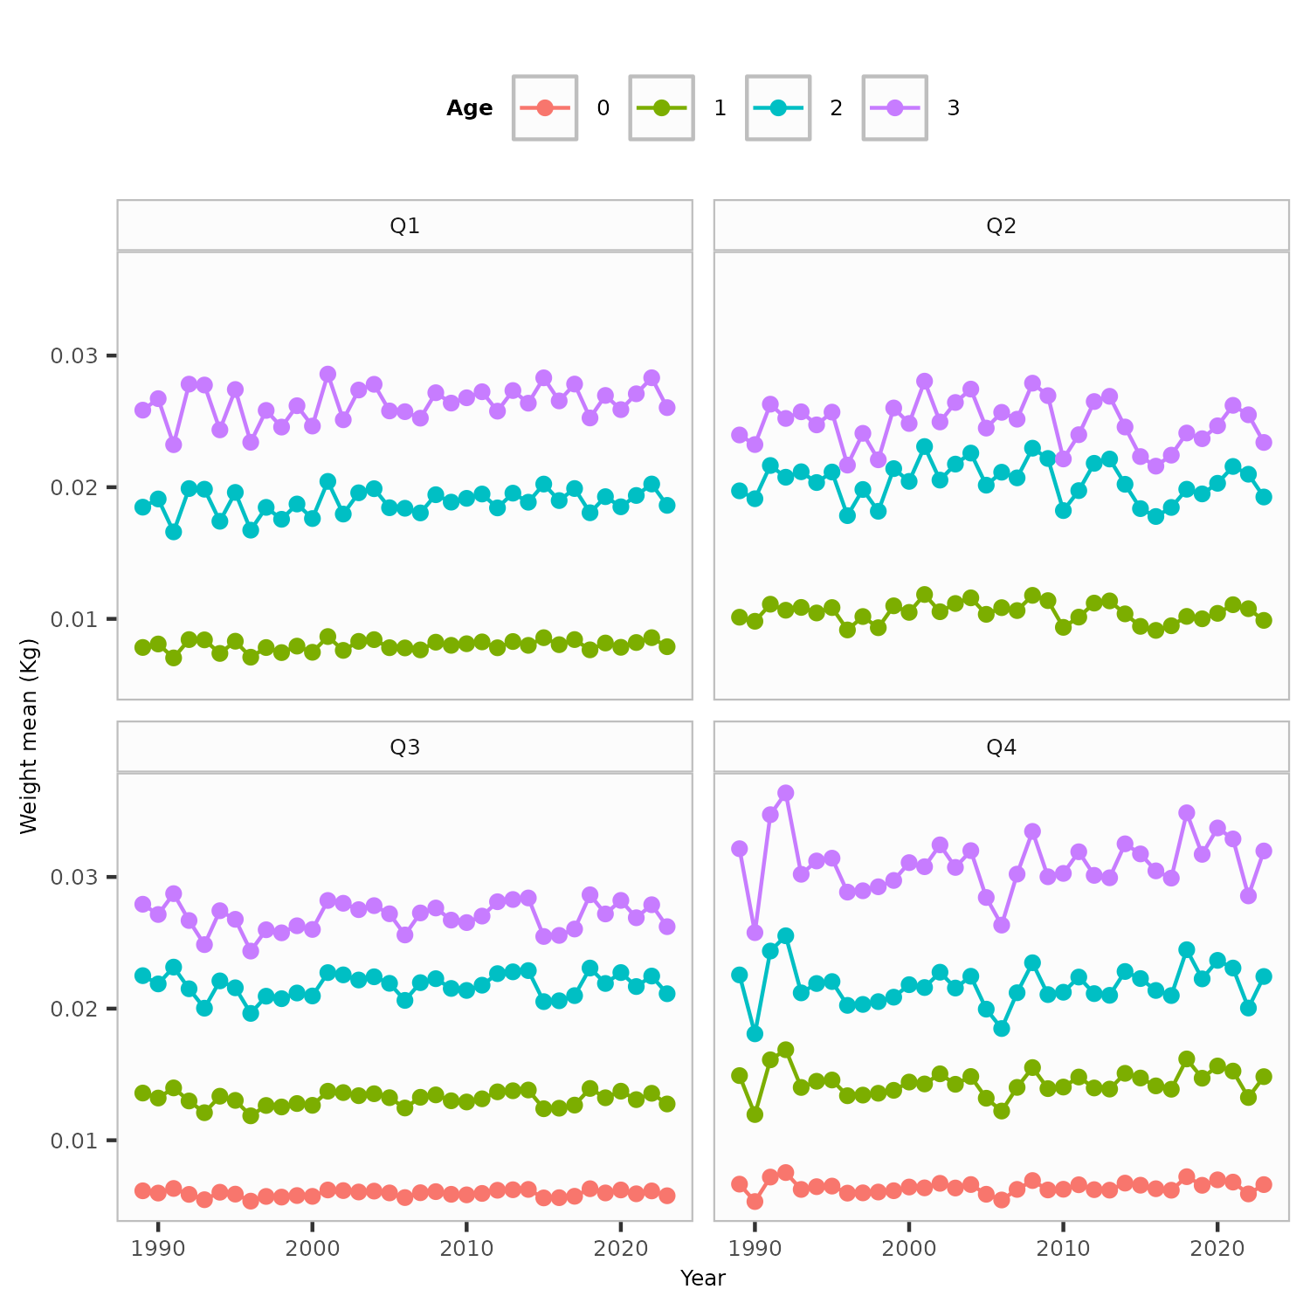 Figure .: Ane.27.9a stock. Weight at age by quarters.

#### *Recruitment*

Annual recruitments are parameters, defined as lognormal deviations (**Figure x**) from **Beverton-Holt** stock-recruitment model (**Figure xx**) with steepness fixed at **XX** and standard deviation of log number of recruits was set to 0.6, the same as in the previous model and based on literature for similar species .

$R_{0}$ = 15.31 $σ_{R}$ = 0.6 steepness $h$ = null

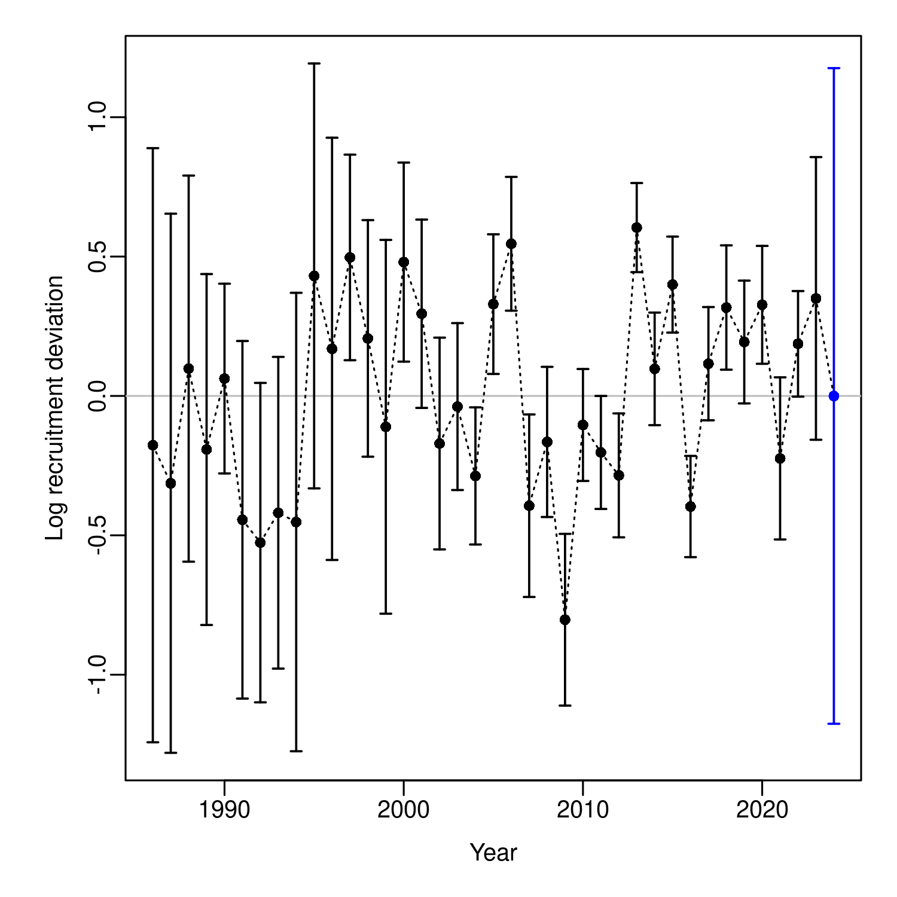 Figure .: Ane.27.9a stock. Recruitment deviation.

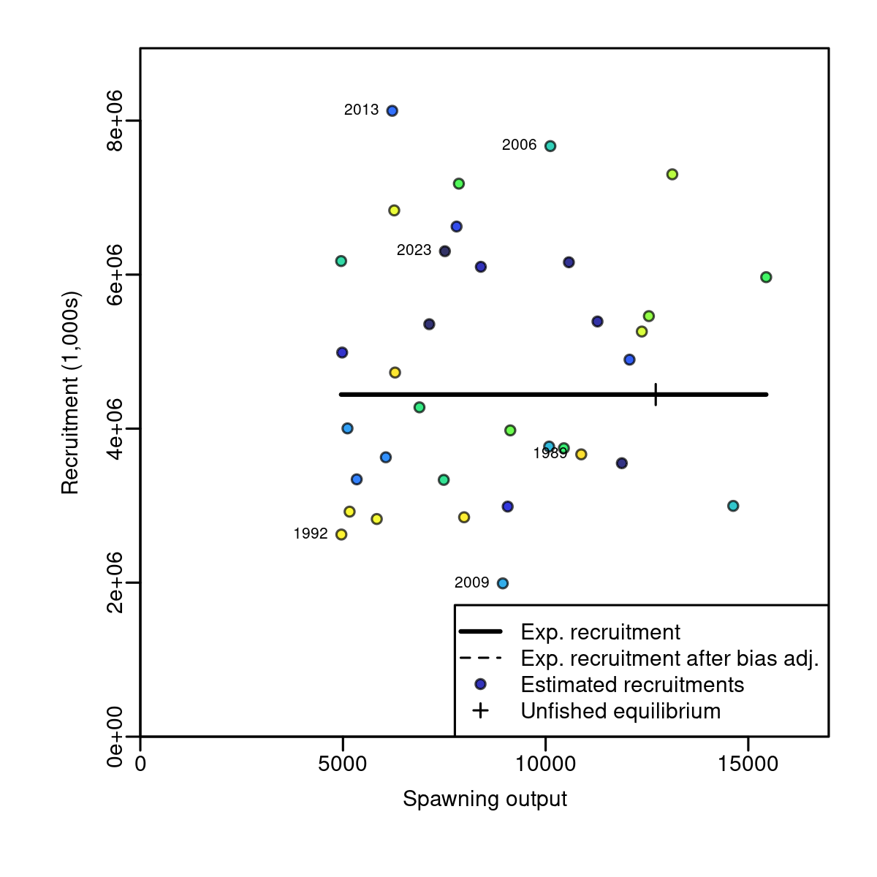 Figure .: Ane.27.9a stock. Stock-recruitment.

#### *Fishing mortality*:

Fishing mortality is applied as the hybrid method does a Pope´s approximation to provide initial values for iterative adjustment of the continuous F values to closely approximate the observed catch.

#### *Catchability*:

The *PELAGO*, *ECOCADIZ*, *ECOCADIZ-RECLUTAS* surveys, and spawning-stock biomass (SSB) from triennial DEPM *BOCADEVA* survey are assumed to be relative indices of abundance. The catchability are modelled with a simple $q$ linear model.

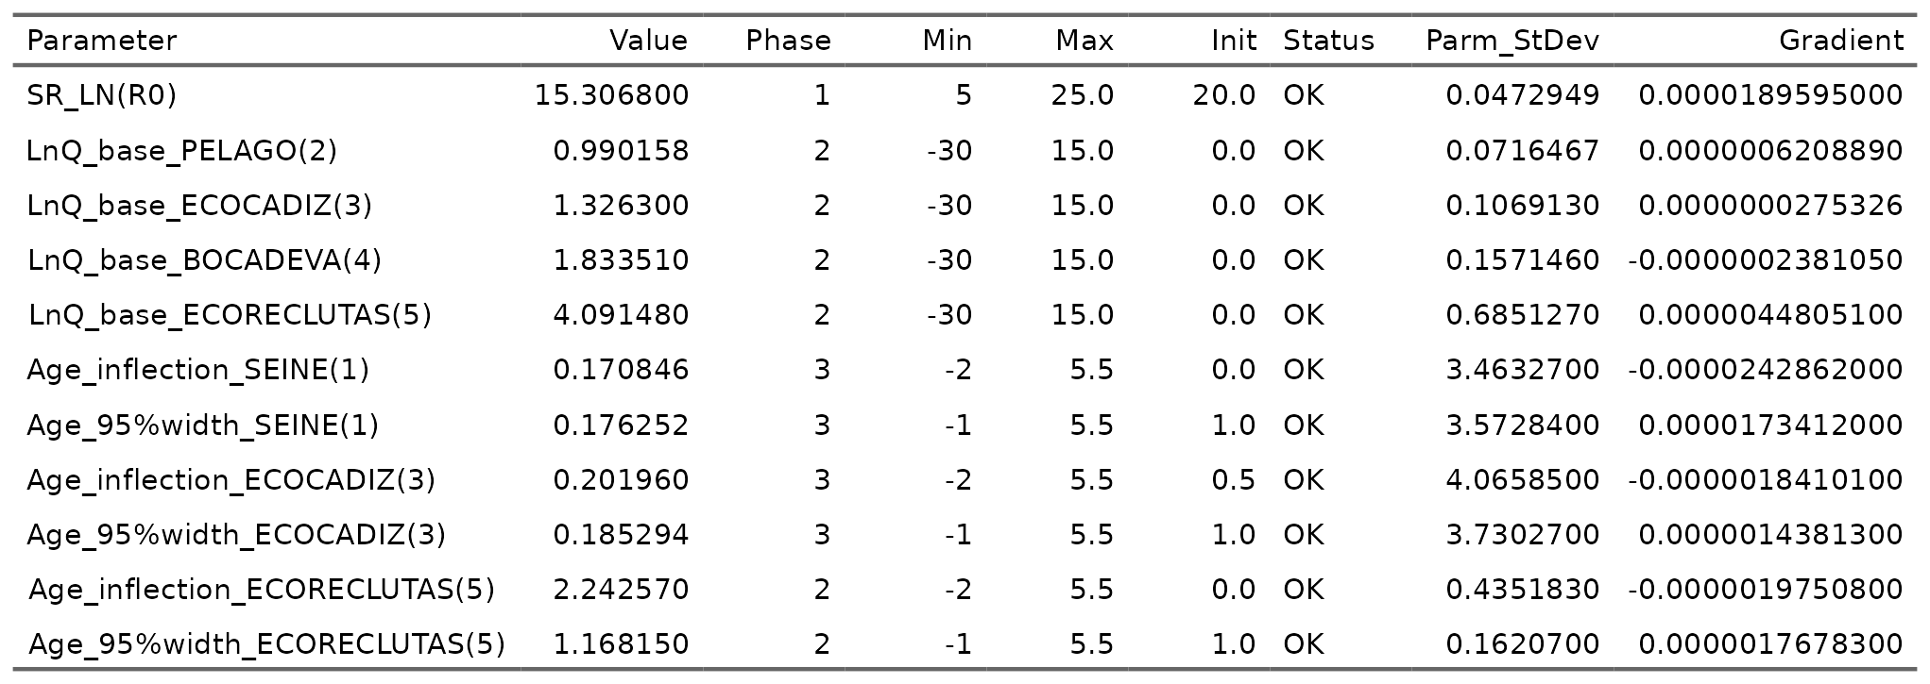

#### *Selectivity*:

The fishery selectivity was set as a logistic function fixed over time… (**Figure xx**). In *PELAGO*, *ECOCADIZ*, *ECOCADIZ-RECLUTAS* surveys was set as a logistic function fixed over time (**Figure xx**).

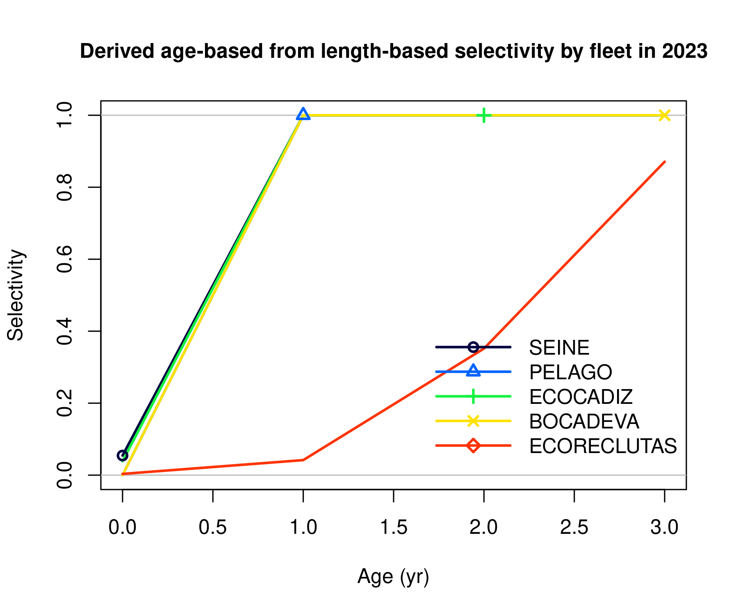

### Time series

The estimated SSB shows an increase from xxx to xxx from xxx thousand tonnes to xxx thousand tonnes. Confidence intervals of SSB are in the range xx-xx% with an average xx%.

The fishing mortality has been relatively stable over the whole time-series and after the slight increase in 2016, showed a decrease in 2017-2023. F0-3 in 2024 was estimated at 0.050 lower than the observed value in 2023 (0.055). Confidence intervals of F with an average of 14%.

The uncertainty in SSB in the most recent years is around 17%. The lack of the combined surveys index could add uncertainty in the present spawning biomass estimates.

However, the new assessment shows lower uncertainty when compared to previous model. The slight decrease in catches observed in 2024 and the increase in estimated stock abundance resulted in a lower estimate of F in 2024 than in the previous year. The uncertainty in the estimated Fbar is of similar magnitude around 11% for the entire period.

The stock shows a strong recruitment in 1996 and average recruitments in the most recent years, with some peaks in 2011, 2012, 2017 and 2022.

Recruitment estimates in the more recent years presents uncertainty as showed in the confidence bars. In 2023, recruitment showed a decrease and was estimated at 330 million individuals.

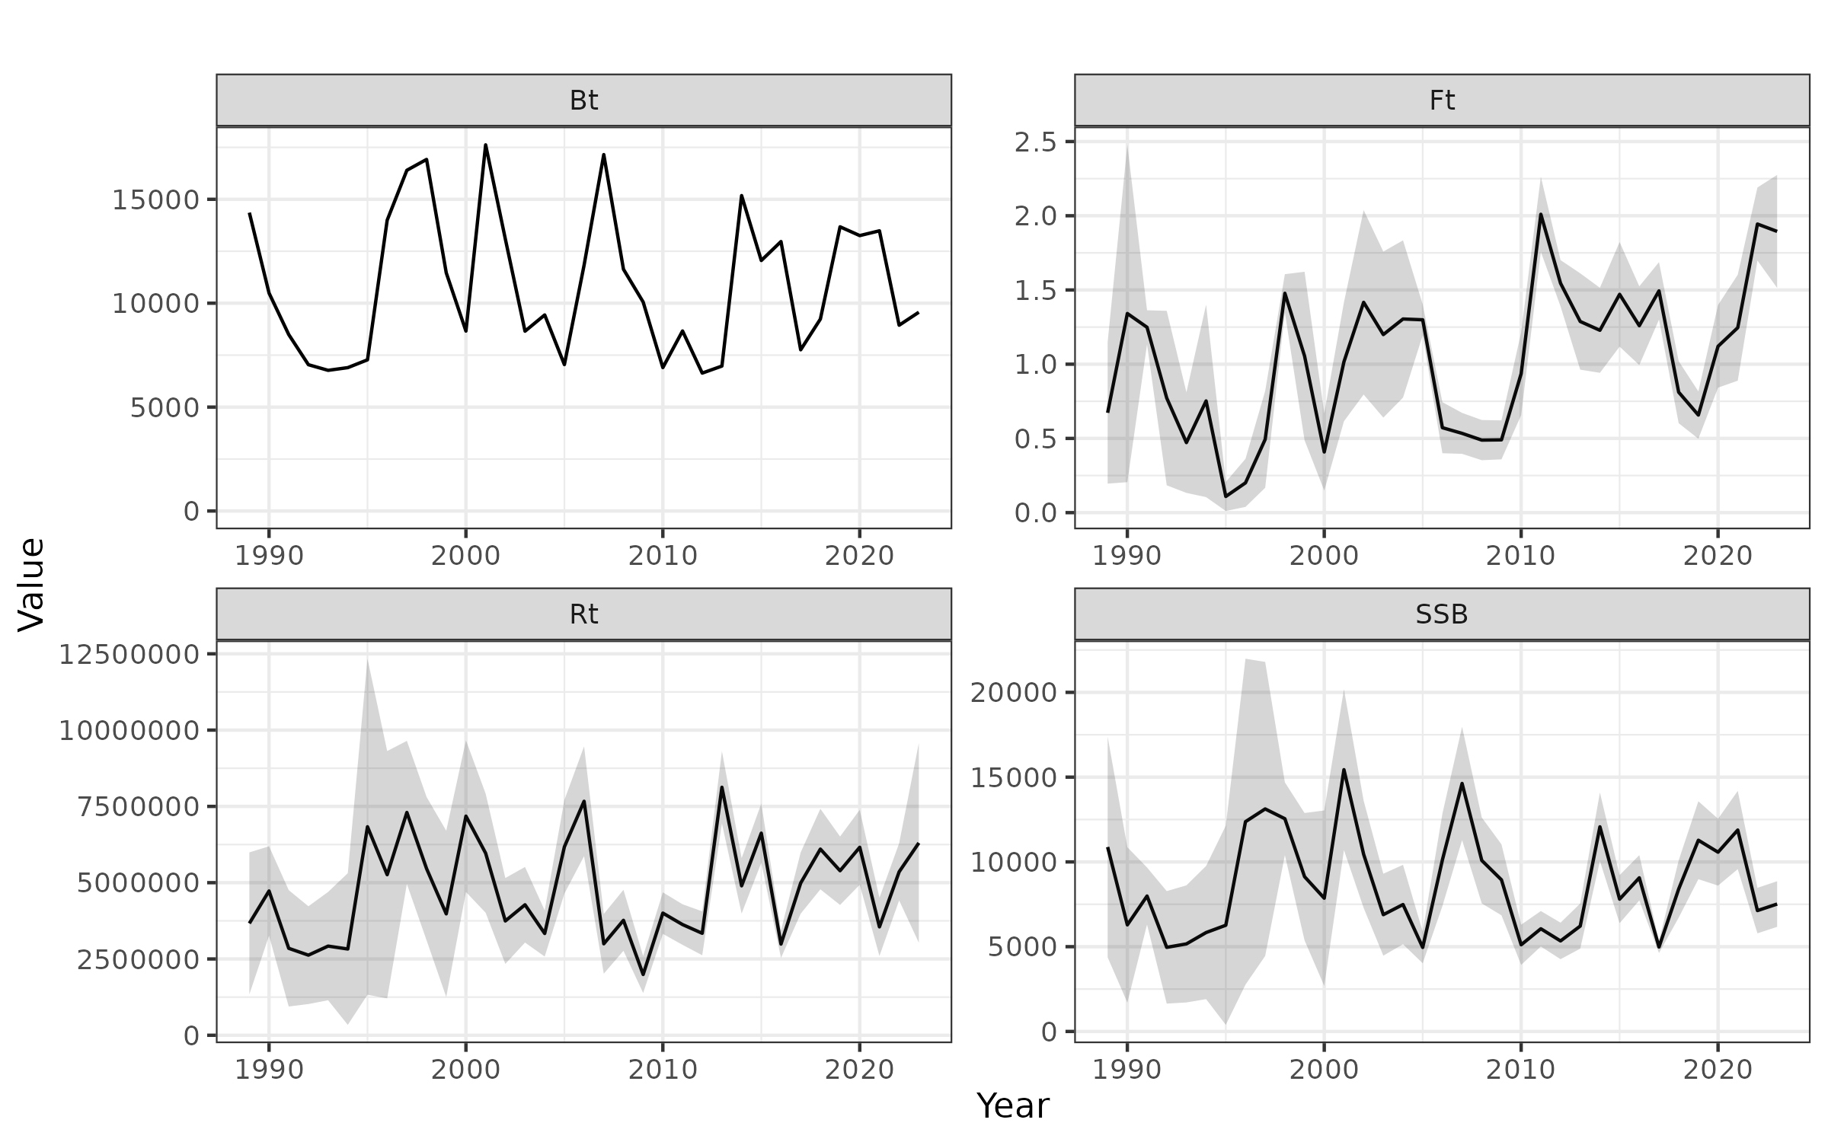

### Fit and residuals indices

In relation to more classical goodness-of-fit analyses, Figure shows that the abundance indices from the acoustic surveys exhibit a high level of variability, summarized by the width of the assumed confidence intervals with a maximum coefficient of variation of 30%.

The model to adequately reproduce the general trend of variability in the biomass levels presented by the survey estimates.

Figure shows that the residuals from the fit of the biomass index of the *PELAGO* survey are not randomly distributed, and the estimate for the year 2016 violates the three-sigma limit of the time series. The estimated root mean square error (RMSE) for the joint residual analysis is 61.7%.

The fit to the aggregated size composition indicates that the commercial fleet achieves a better fit than the size compositions from the acoustic surveys (Figure ). However, Figures run_reference("fig_runtest_residuals_indices") to demonstrate poor performance when showing the fit to the size compositions disaggregated by quarter and year.

The behavior of the residuals from the size compositions suggests an underestimation of small sizes (<10 cm) and an overestimation of large sizes (>15 cm) in the commercial fleet and *PELAGO* acoustic survey (Figure ).

The residuals from the *ECOCADIZ* acoustic survey indicate an underestimation of intermediate sizes (between 10 and 15 cm) and an overestimation of large sizes (>15 cm), while the *ECOCADIZ-RECLUTAS* survey shows an underestimation of small sizes (<10 cm) and an overestimation of intermediate sizes (between 10 and 15 cm) (Figure ).

The assumption of annual invariability in exploitation patterns as a measure of parsimony, and the poor specification of recruitment could be causing these mismatches and high residuals in the size compositions.

Figure shows that the residuals from the fit of the size compositions of the commercial fleet are randomly distributed. Additionally, there is a violation of the three-standard-deviation limit in the years 1991, 1996, 2016, and 2021. In contrast, for the fit of the size compositions from the three acoustic surveys, the hypothesis of a randomly distributed residual time series is rejected.

The estimated root mean square error (RMSE) for the joint residual analysis is 20.6%.

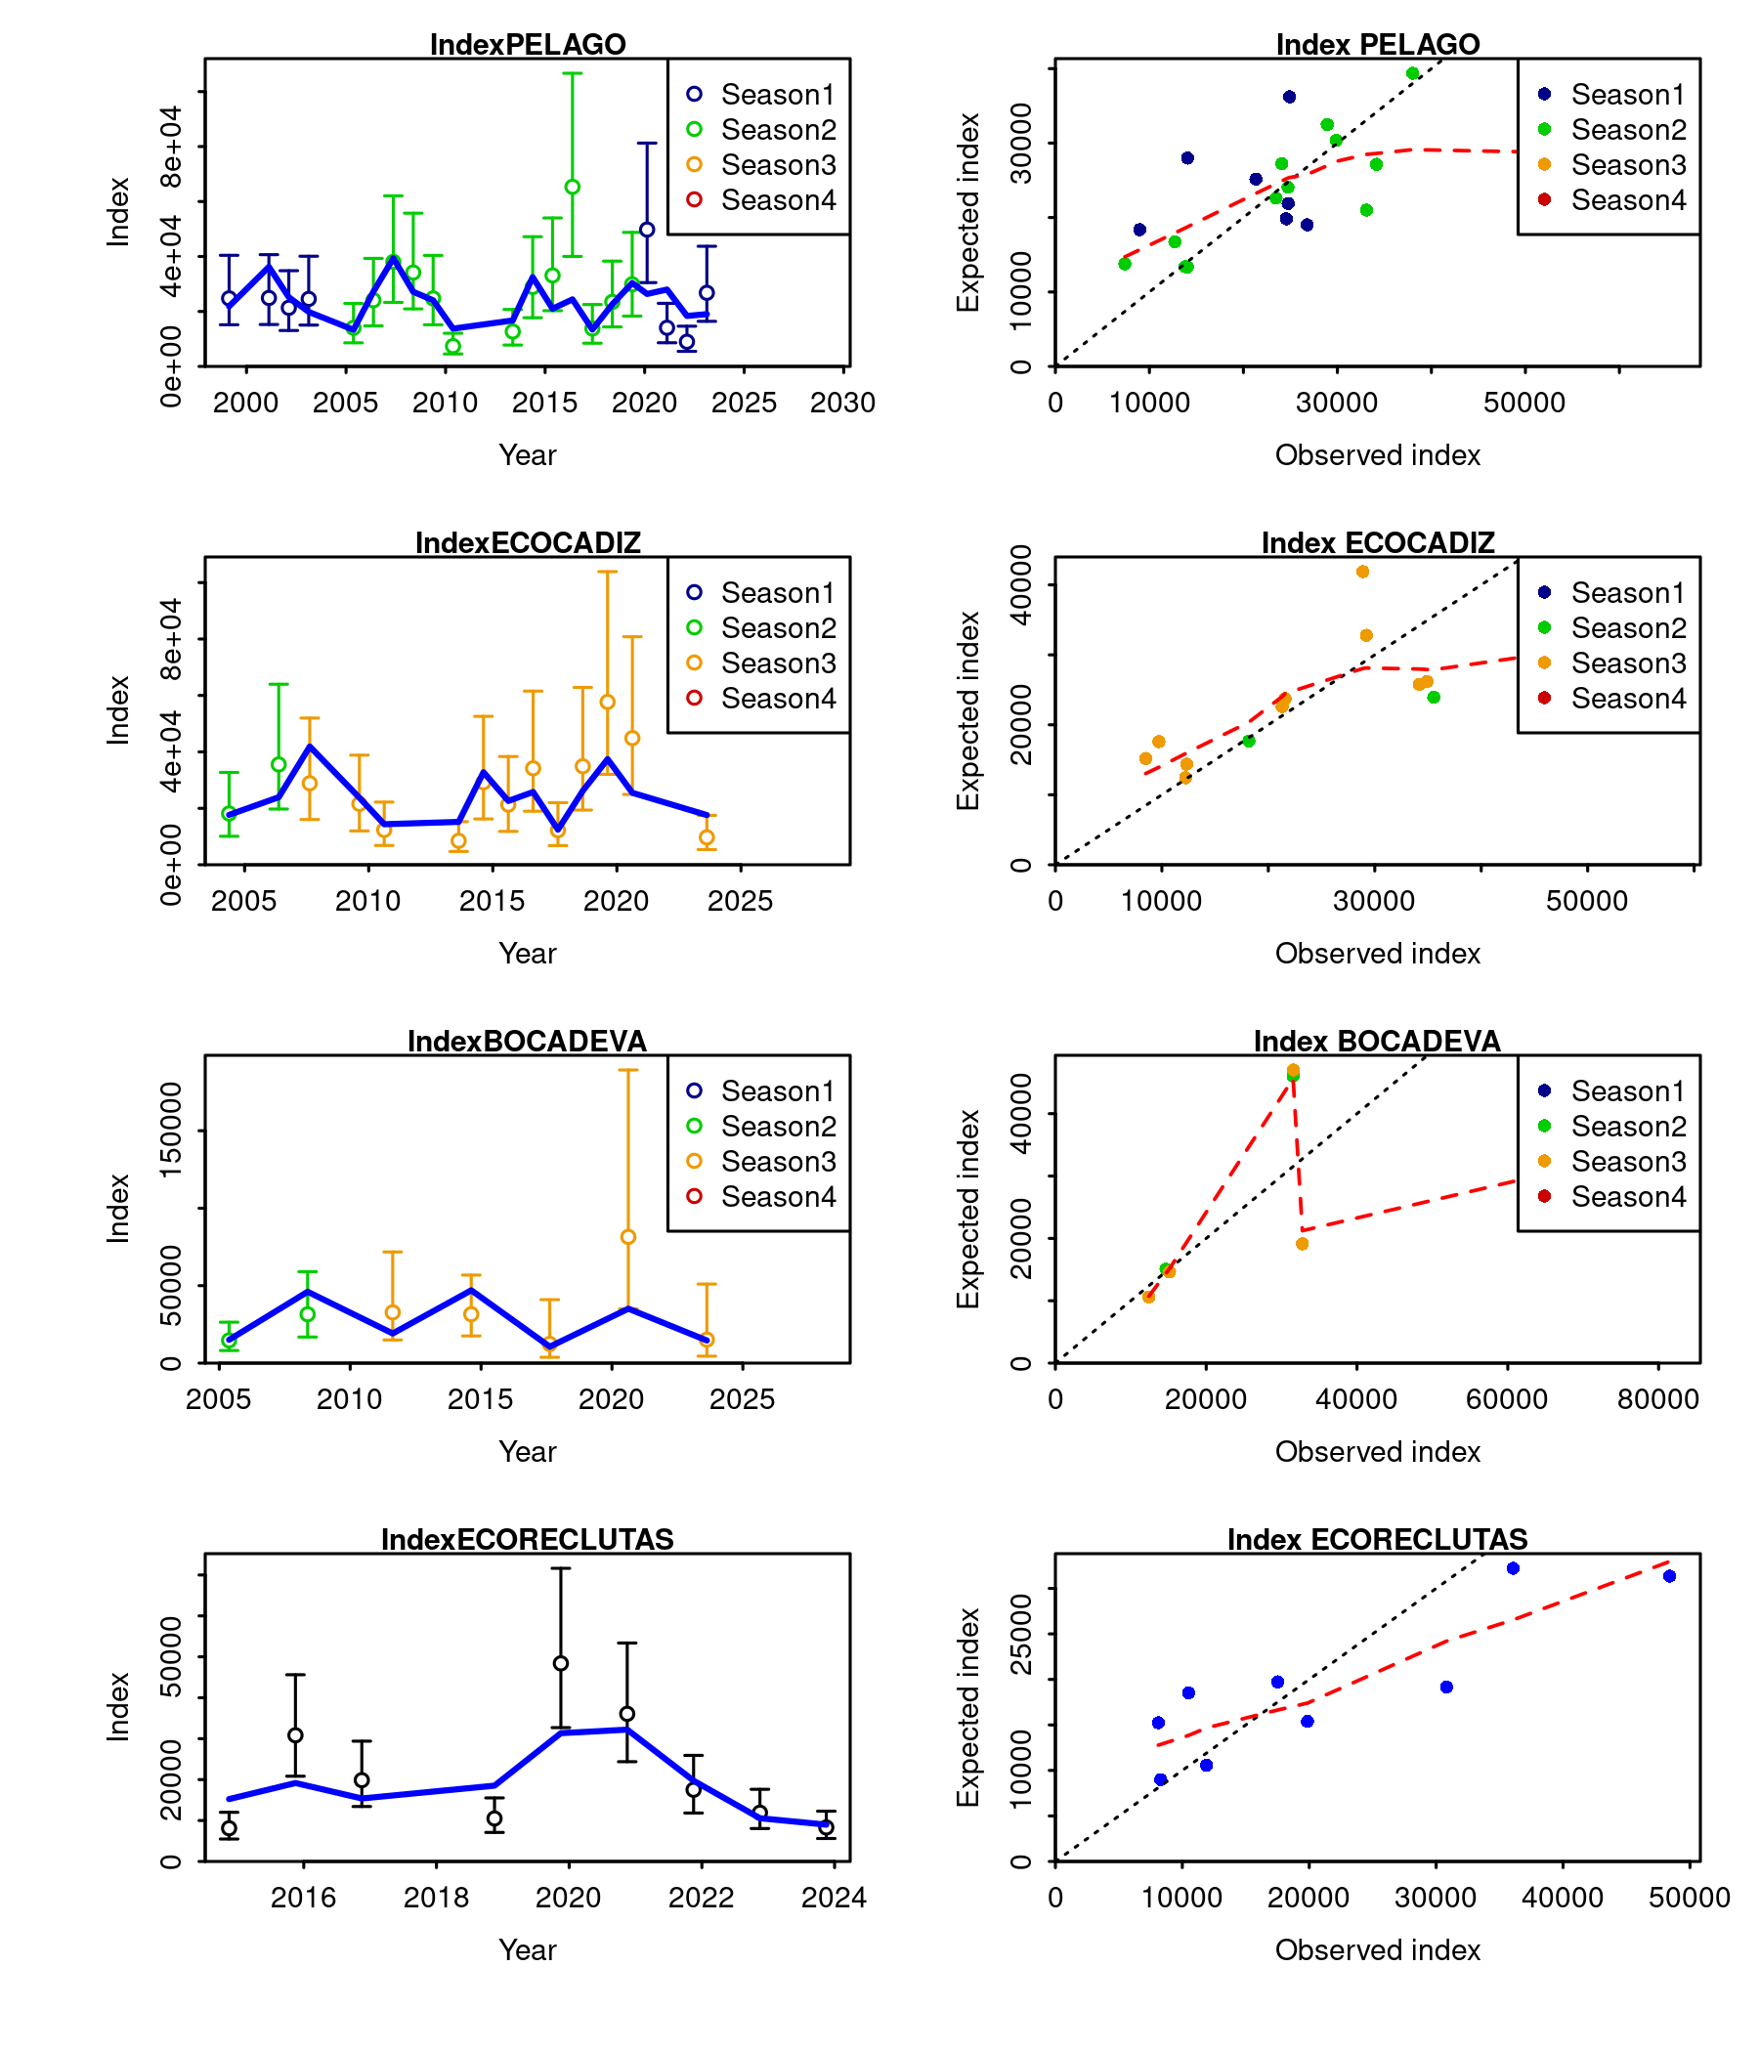

Figure .: Ane.27.9a stock. Model fit to the data (left panel) and observed versus expected values (right panel) of the indices from the acoustic surveys *PELAGO*, *ECOCADIZ*, *BOCADEVA* and *ECOCADIZ-RECLUTAS*. The lines indicate a 95% uncertainty interval around the index values based on the lognormal error model assumption.

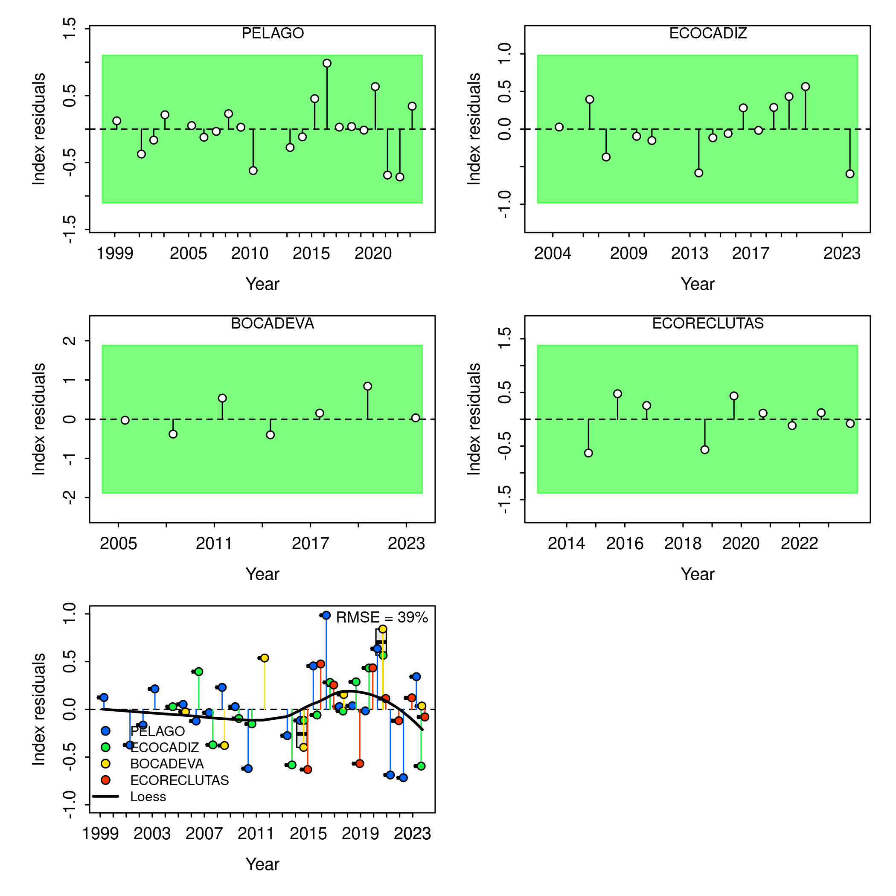

Figure .: Ane.27.9a stock. Run test plots for the fit of acoustic survey indices. Green shading indicates no evidence (p=0.05) and red shading indicates evidence (p<0.05) for rejecting the hypothesis of a randomly distributed residual time series, respectively. The shaded area (green/red) spans three standard residual deviations on either side of zero, and red points outside the shading violate the three-sigma limit for that series. The boxplot of joint residuals indicates the median and quantiles in cases where residuals from multiple indices are available for a given year, with the solid black line showing a loess smoother. The root mean square errors (RMSE) are included in the top right corner of the boxplot.

Table .: Ane.27.9a stock. test residuals.

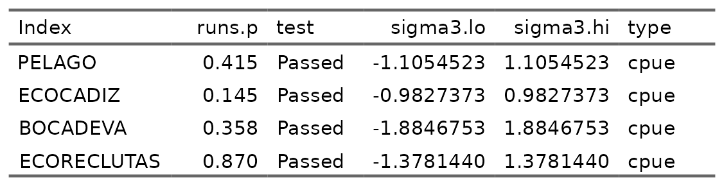

Table .: Ane.27.9a stock. test residuals2.

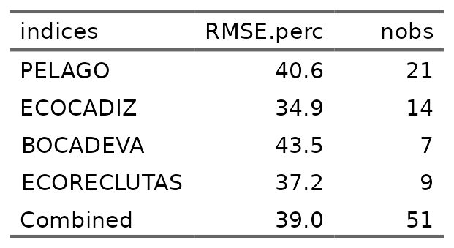

#### Fit and residuals age composition

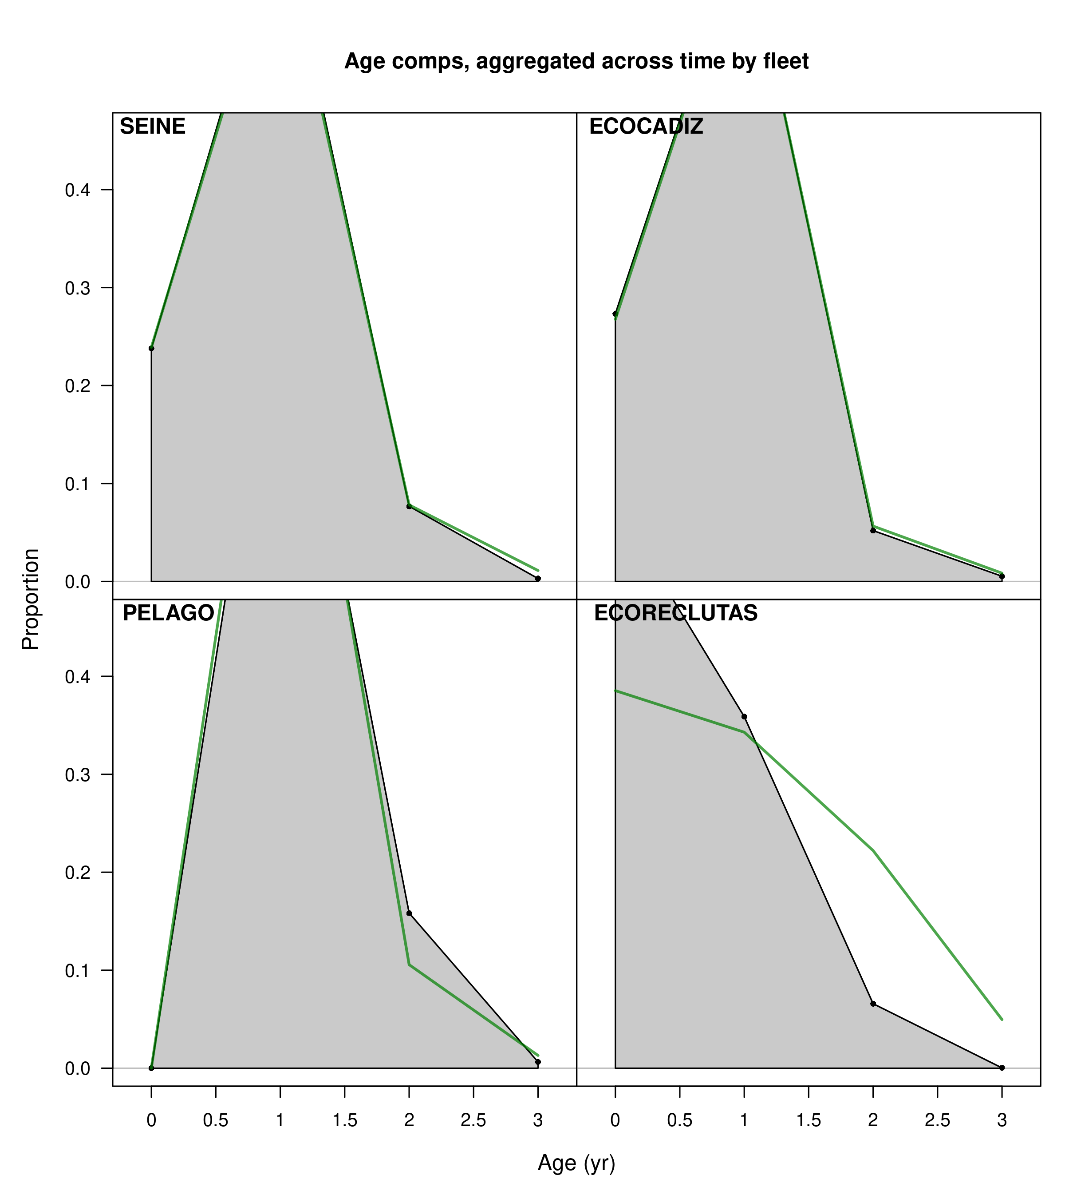

Figure .: Ane.27.9a stock. Model fit to the aggregated age composition data from the SEINE fishery, and the acoustic surveys *PELAGO*, *ECOCADIZ*, and *ECOCADIZ-RECLUTAS*. The green line represents the model estimates, while the shaded gray area shows the observed data.

##### *SEINE* Fleet by quarters

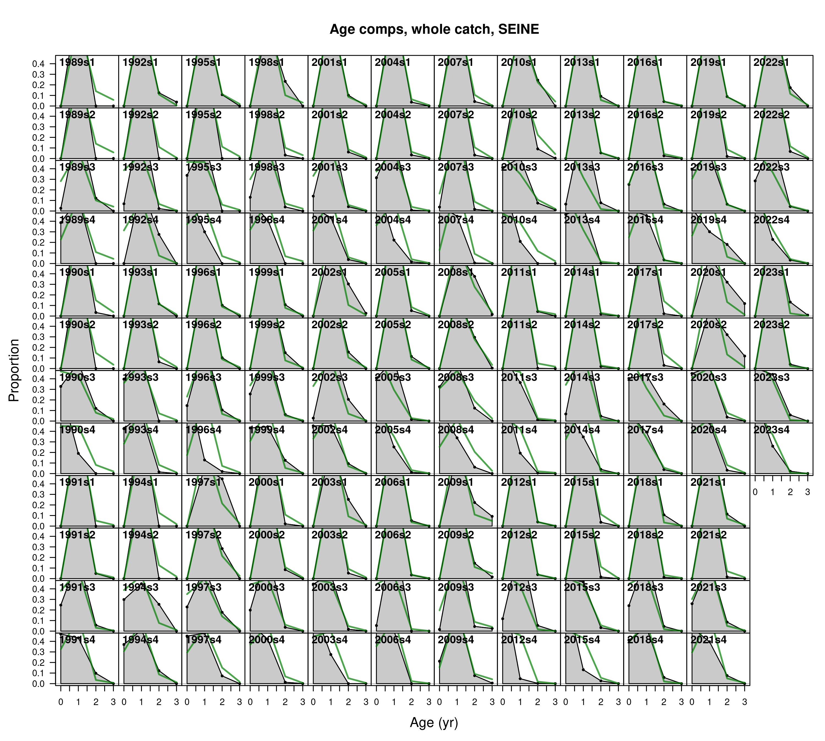

Figure .: Ane.27.9a stock. Model fit to the age composition data from the *SEINE* fishery, by year and quarter. The green line represents the model estimates, while the shaded gray area shows the observed data.

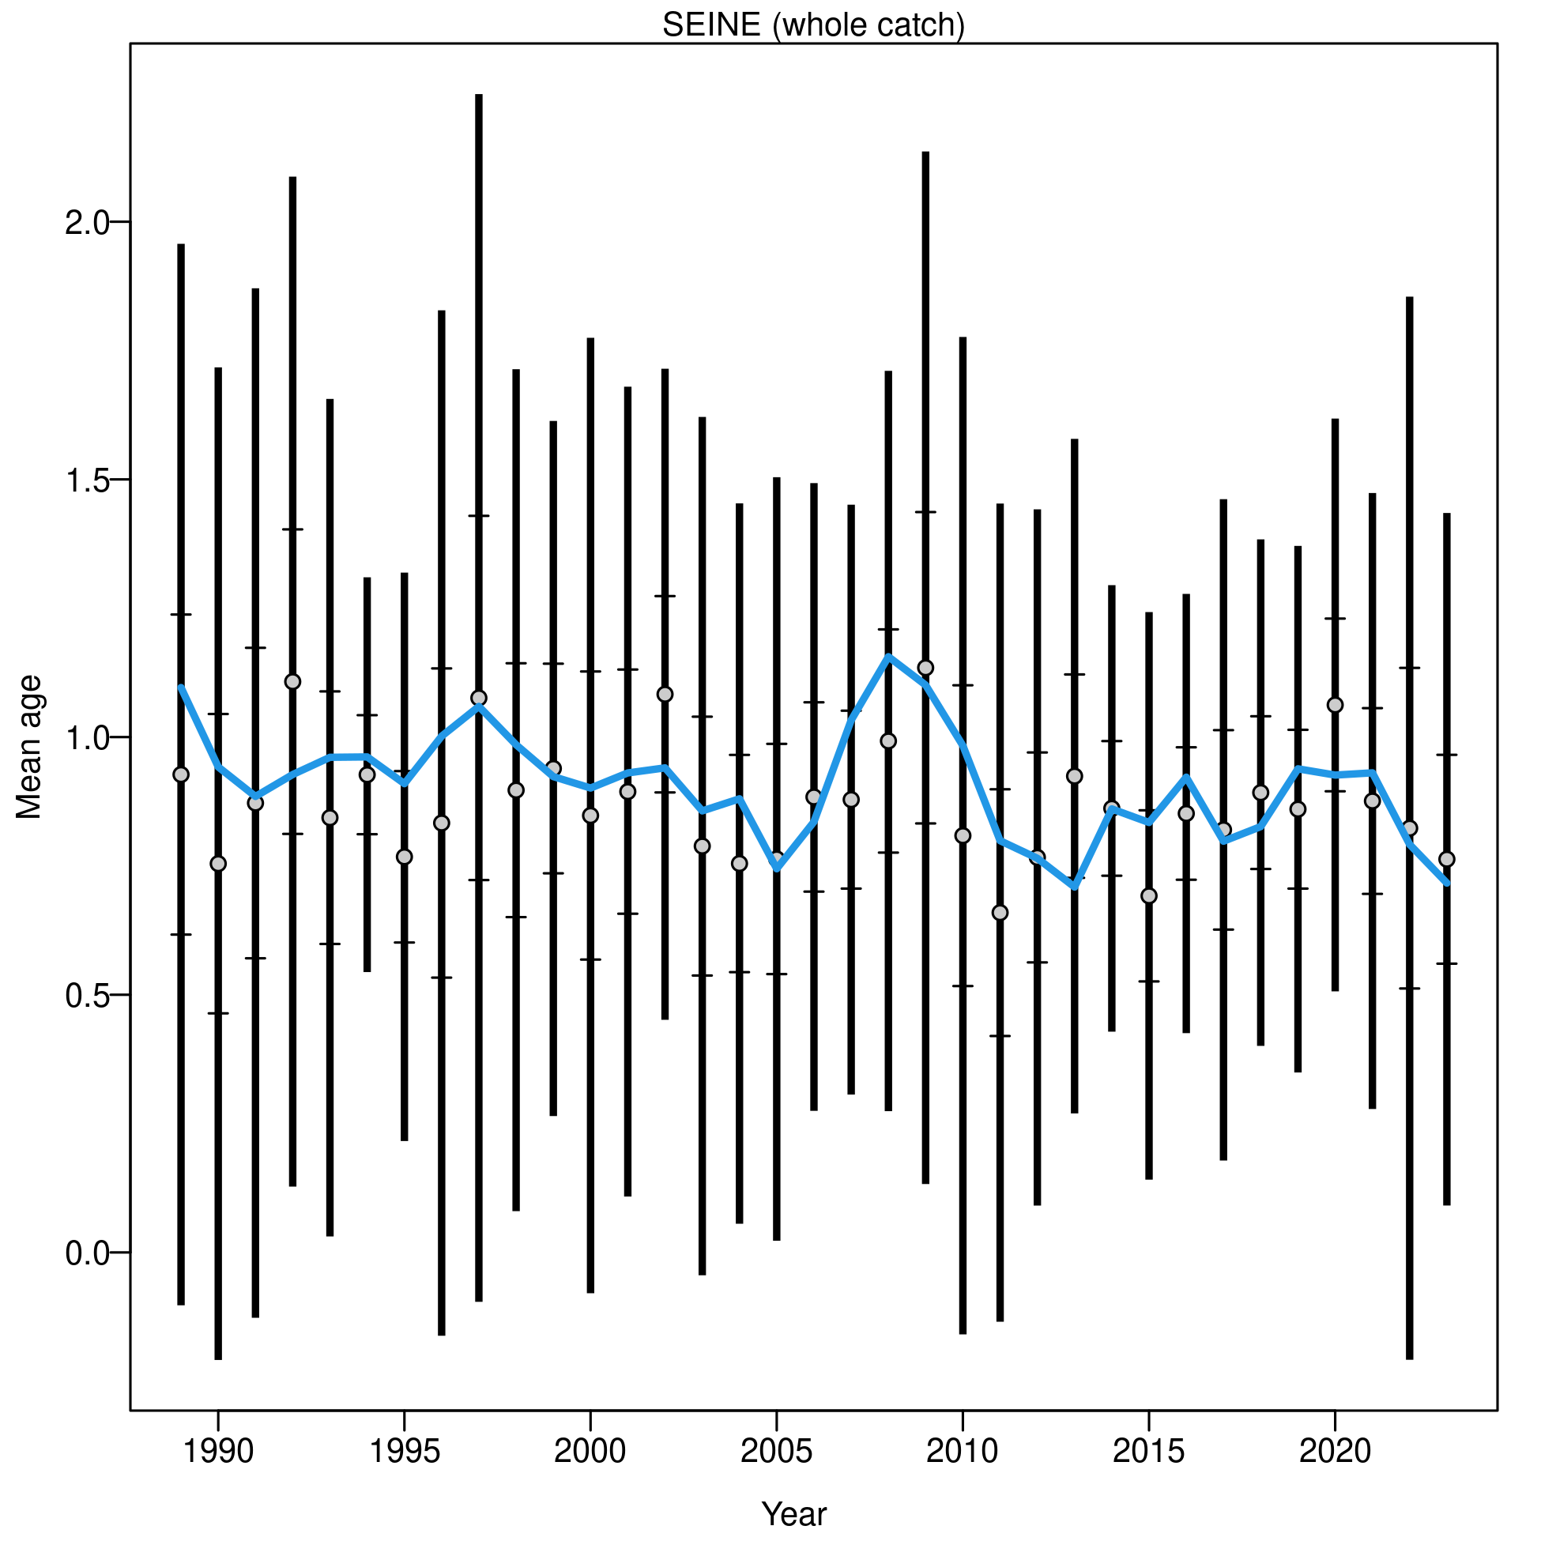

Figure .: Ane.27.9a stock. Mean age for *SEINE* with 95% confidence intervals based on current sample sizes. Francis data weighting method TA1.8: thinner intervals (with capped ends) show the result of further adjusting sample sizes based on the suggested multiplier (with 95% interval) for age data from *SEINE*. The blue line corresponds to the estimated mean age.

##### *PELAGO* spring survey

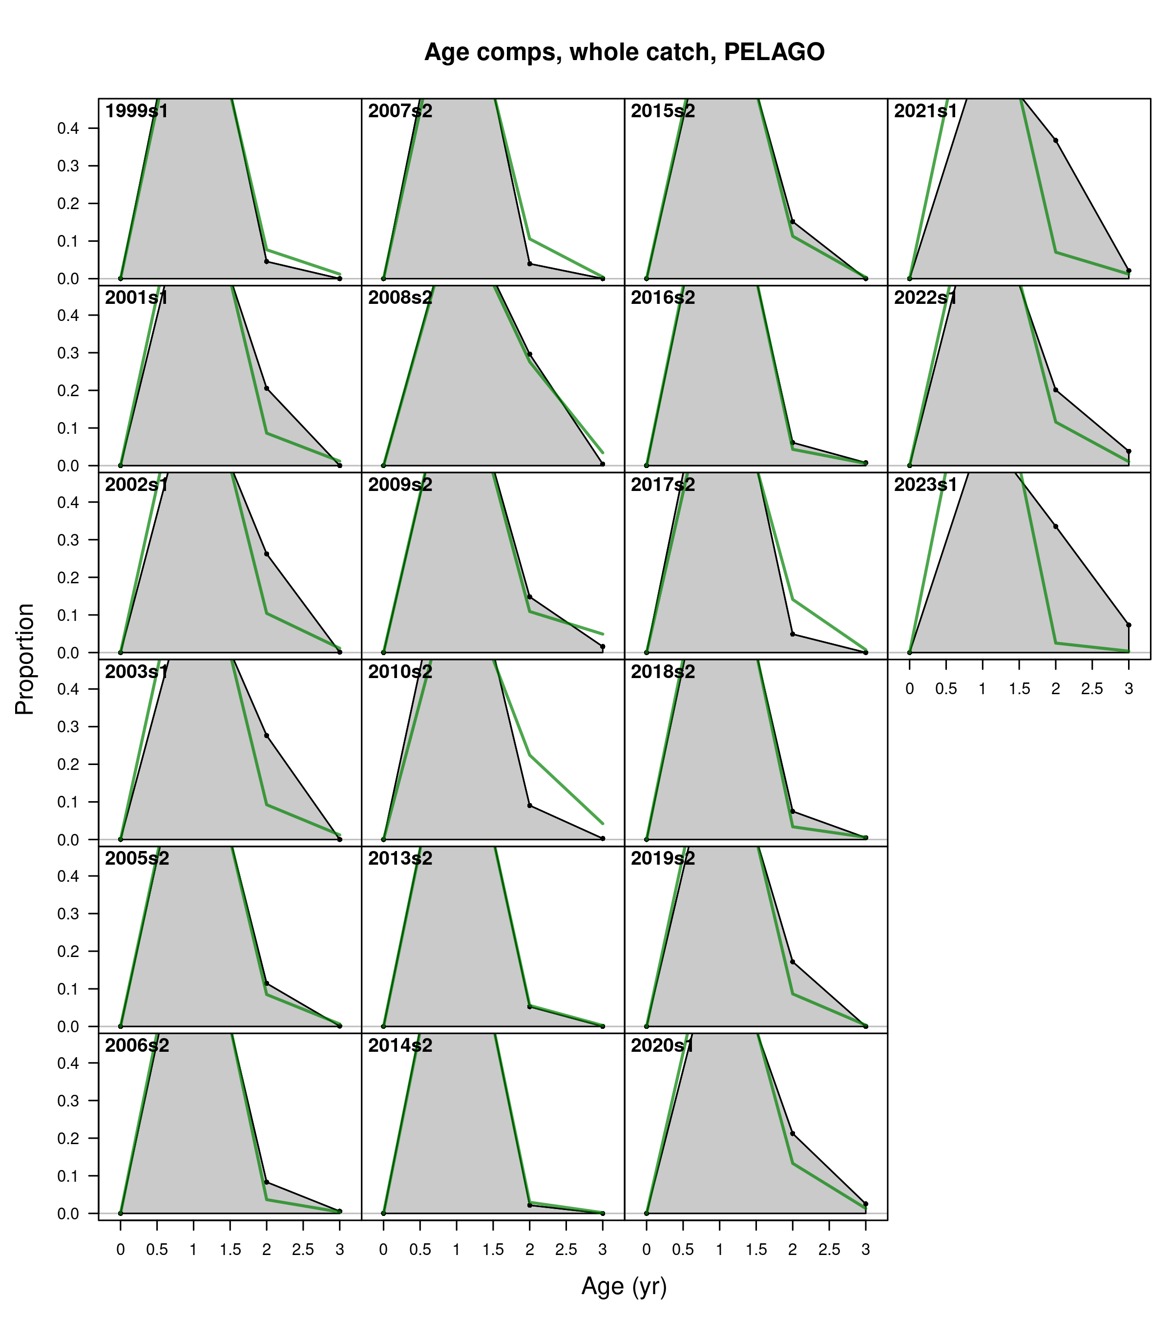

Figure .: Ane.27.9a stock. Model fit to the age composition data from the *PELAGO* spring survey by year. The green line represents the model estimates, while the shaded gray area shows the observed data.

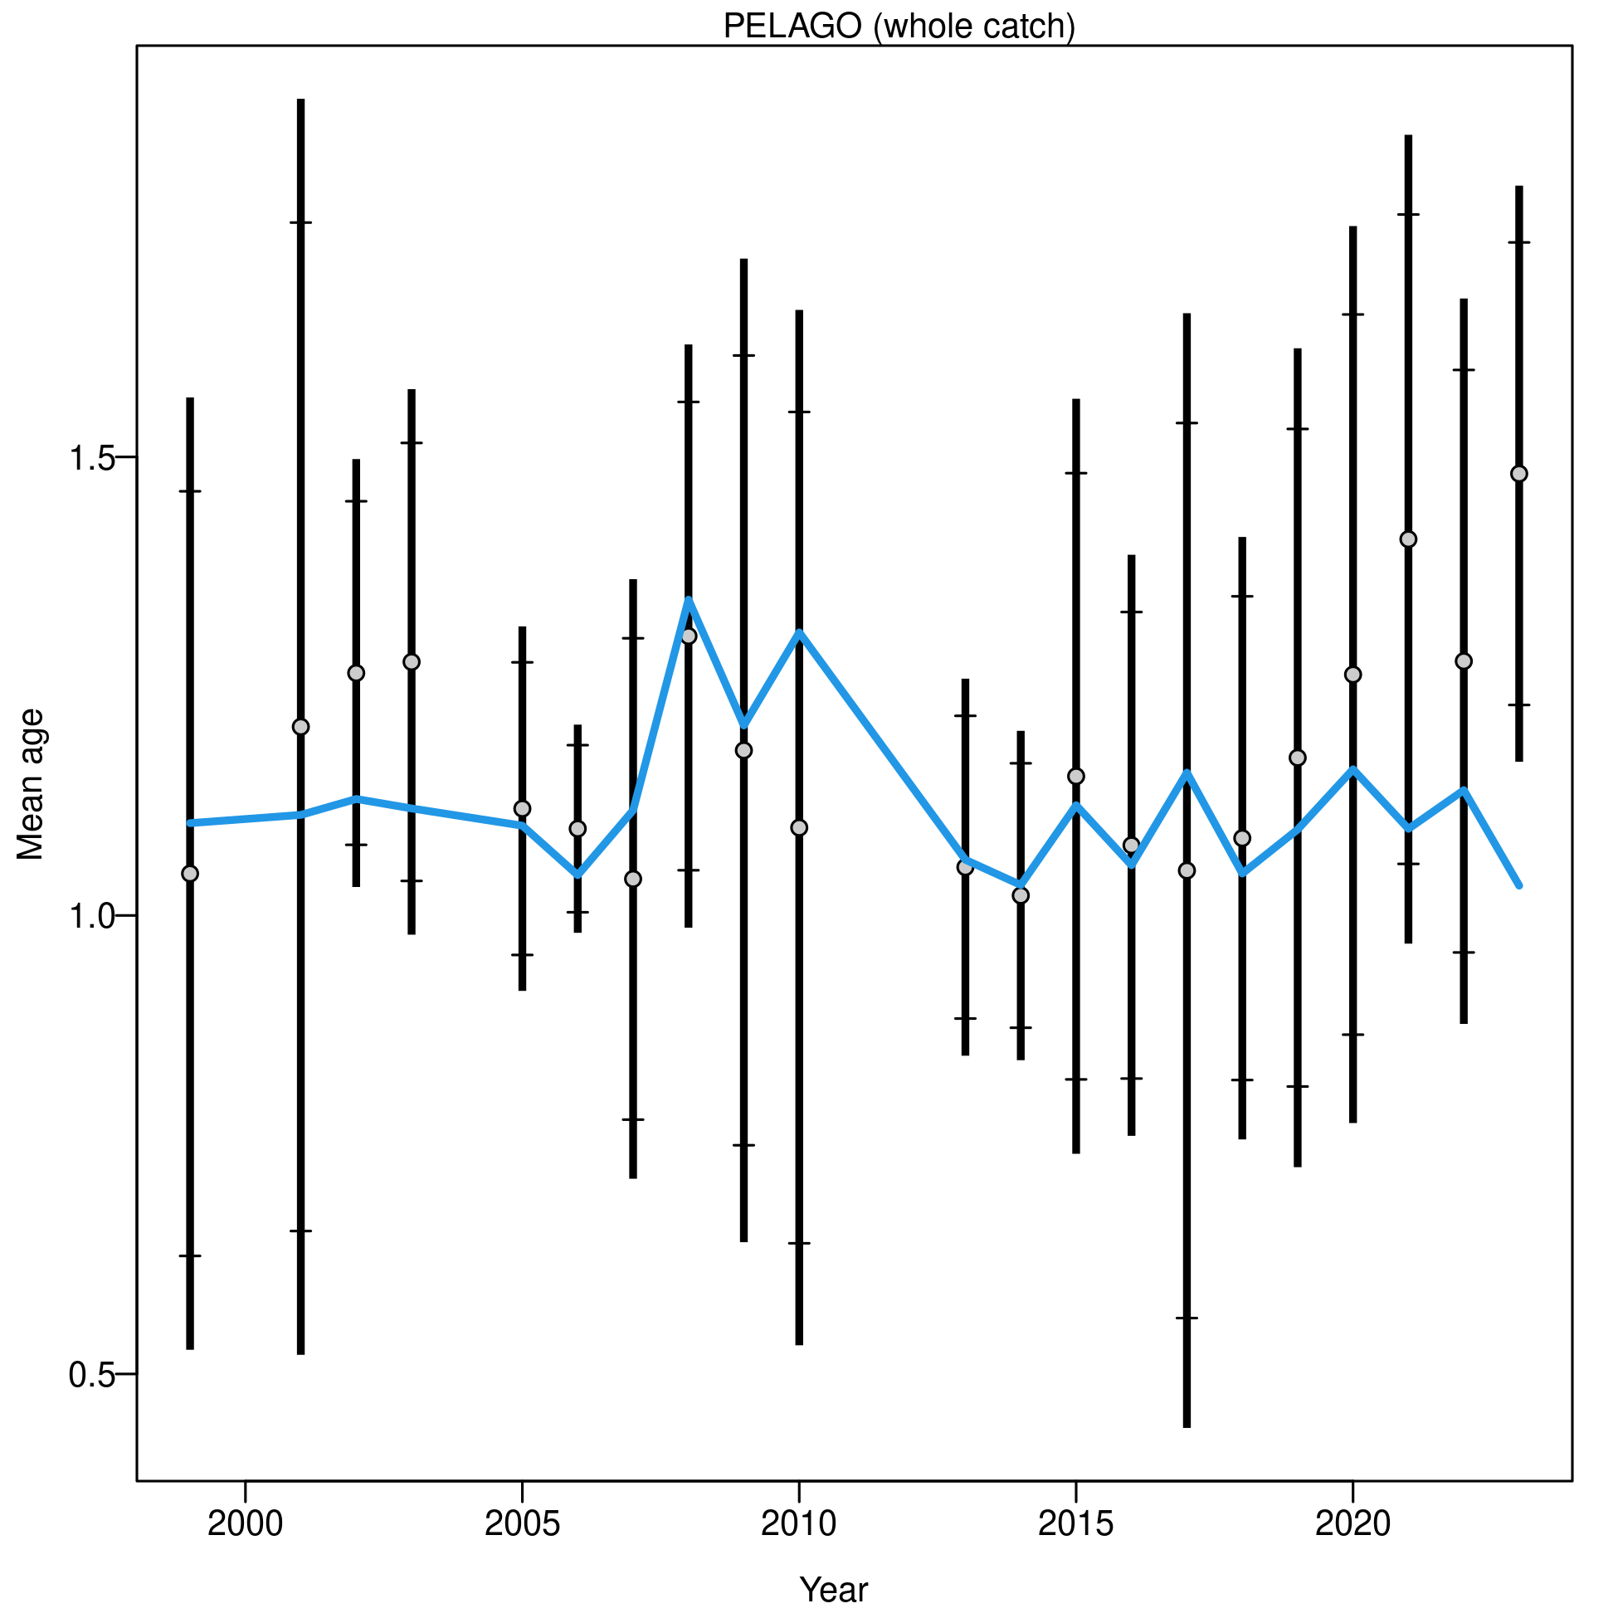

Figure .: Ane.27.9a stock. Mean age for *PELAGO* with 95% confidence intervals based on current sample sizes. Francis data weighting method TA1.8: thinner intervals (with capped ends) show the result of further adjusting sample sizes based on the suggested multiplier (with 95% interval) for age data from *PELAGO*. The blue line corresponds to the estimated mean age.

##### *ECOCADIZ* summer survey

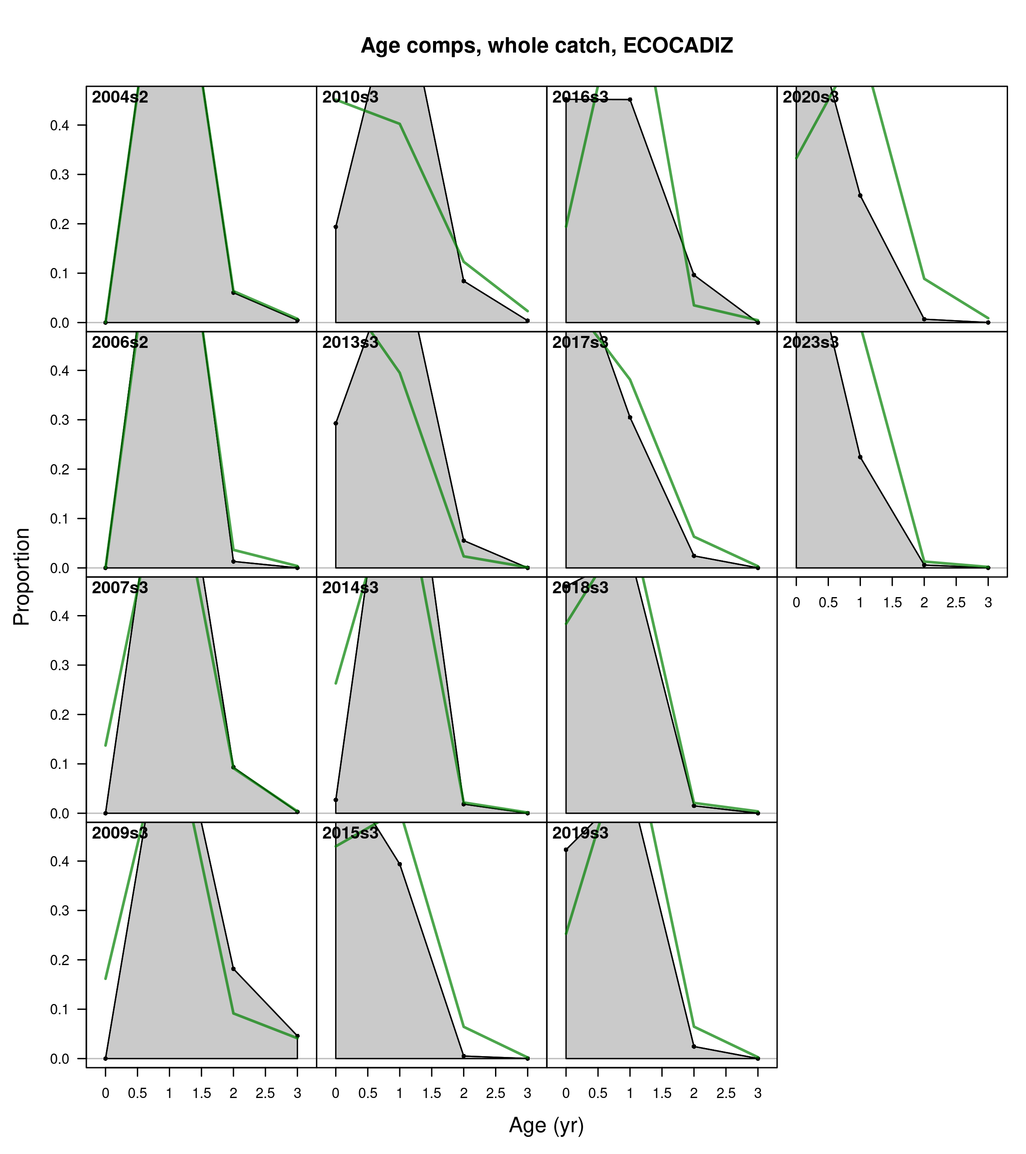

Figure .: Ane.27.9a stock. Model fit to the age composition data from the *ECOCADIZ* summer survey by year. The green line represents the model estimates, while the shaded gray area shows the observed data.

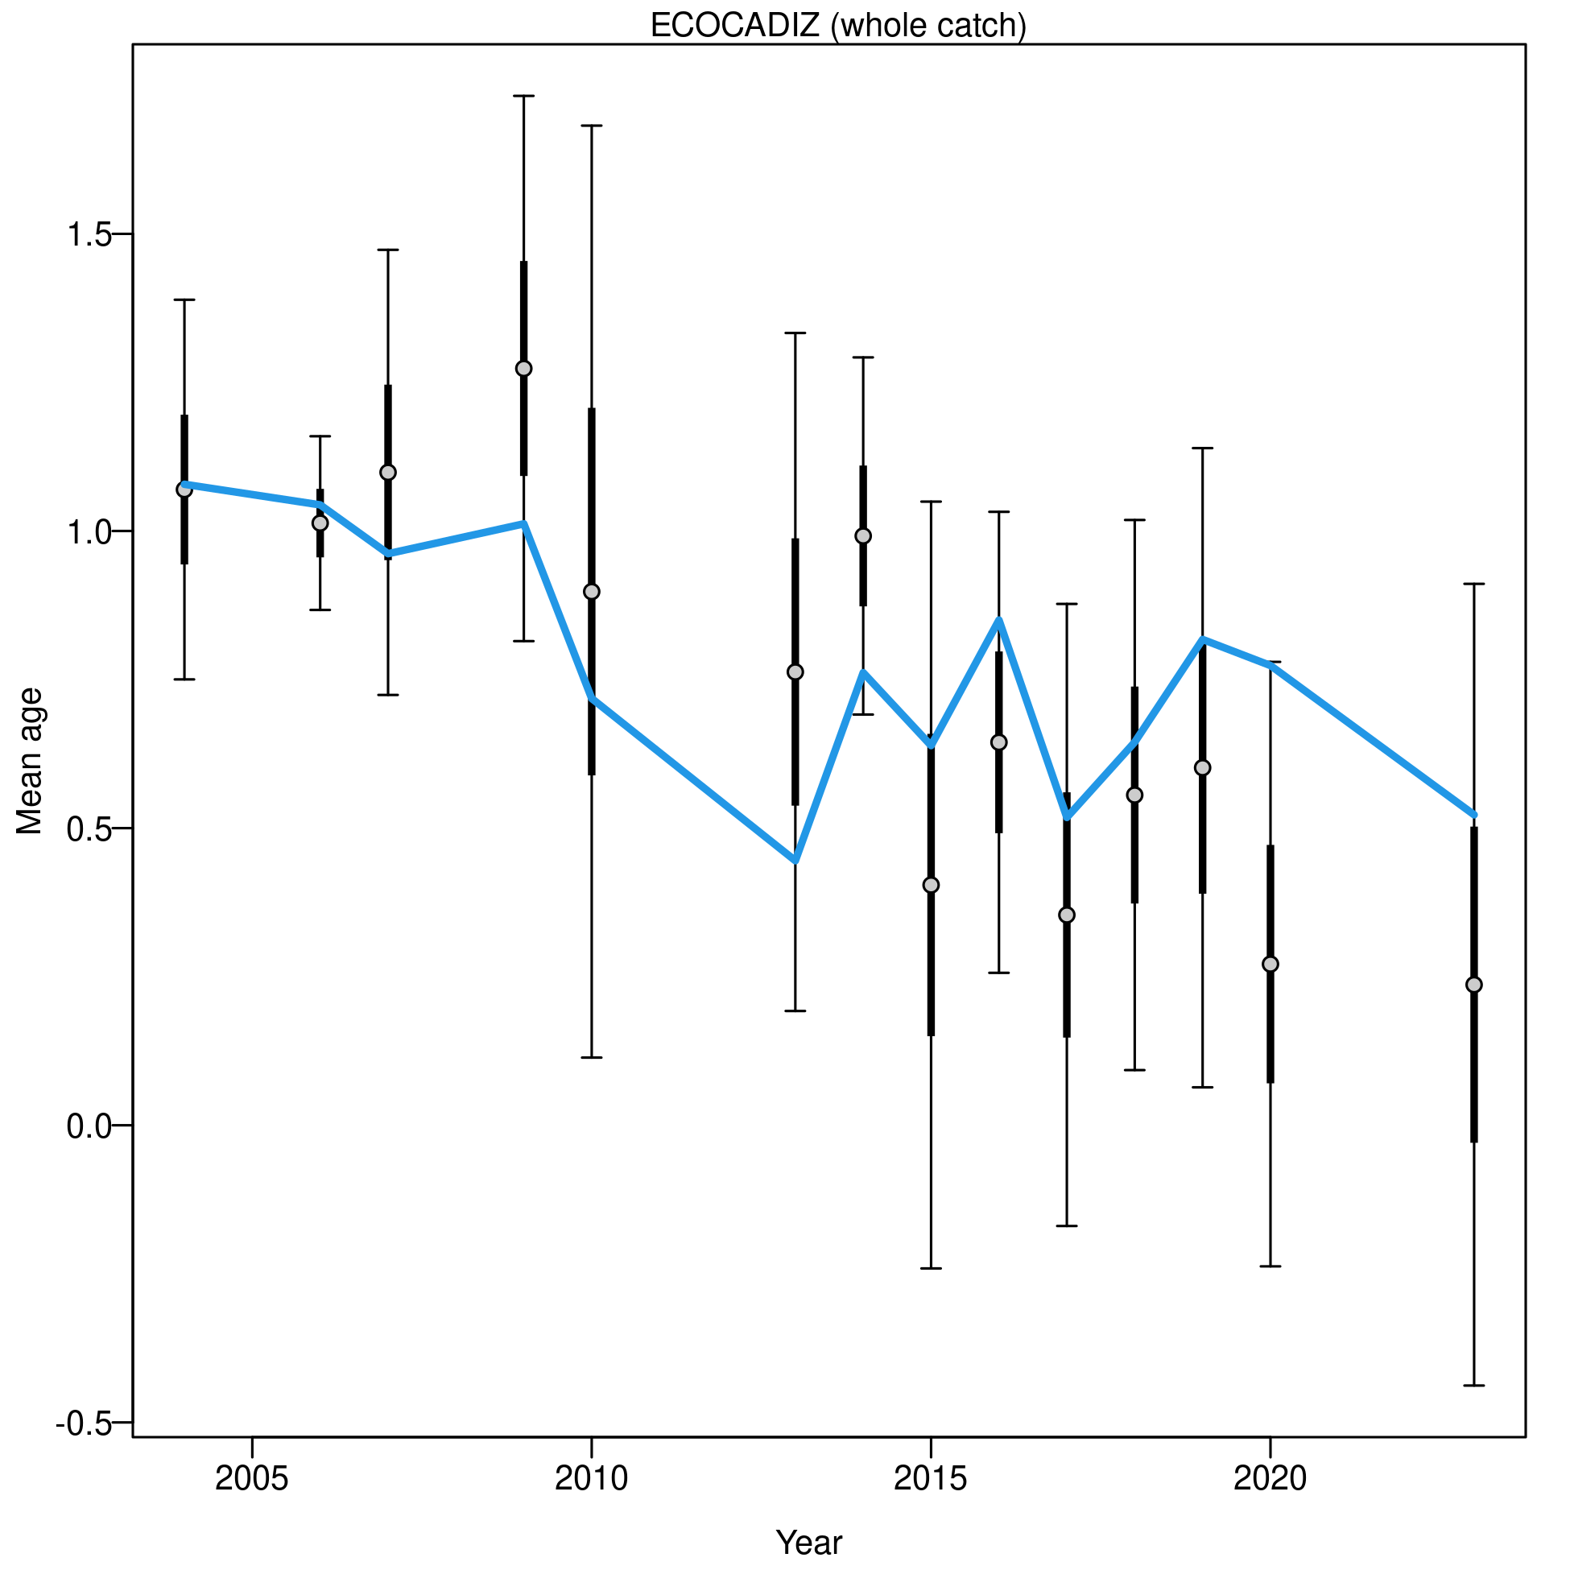

Figure .: Ane.27.9a stock. Mean age for *ECOCADIZ* with 95% confidence intervals based on current sample sizes. Francis data weighting method TA1.8: thinner intervals (with capped ends) show the result of further adjusting sample sizes based on the suggested multiplier (with 95% interval) for age data from *ECOCADIZ*. The blue line corresponds to the estimated mean age.

##### *ECOCADIZ-RECLUTAS* fall survey

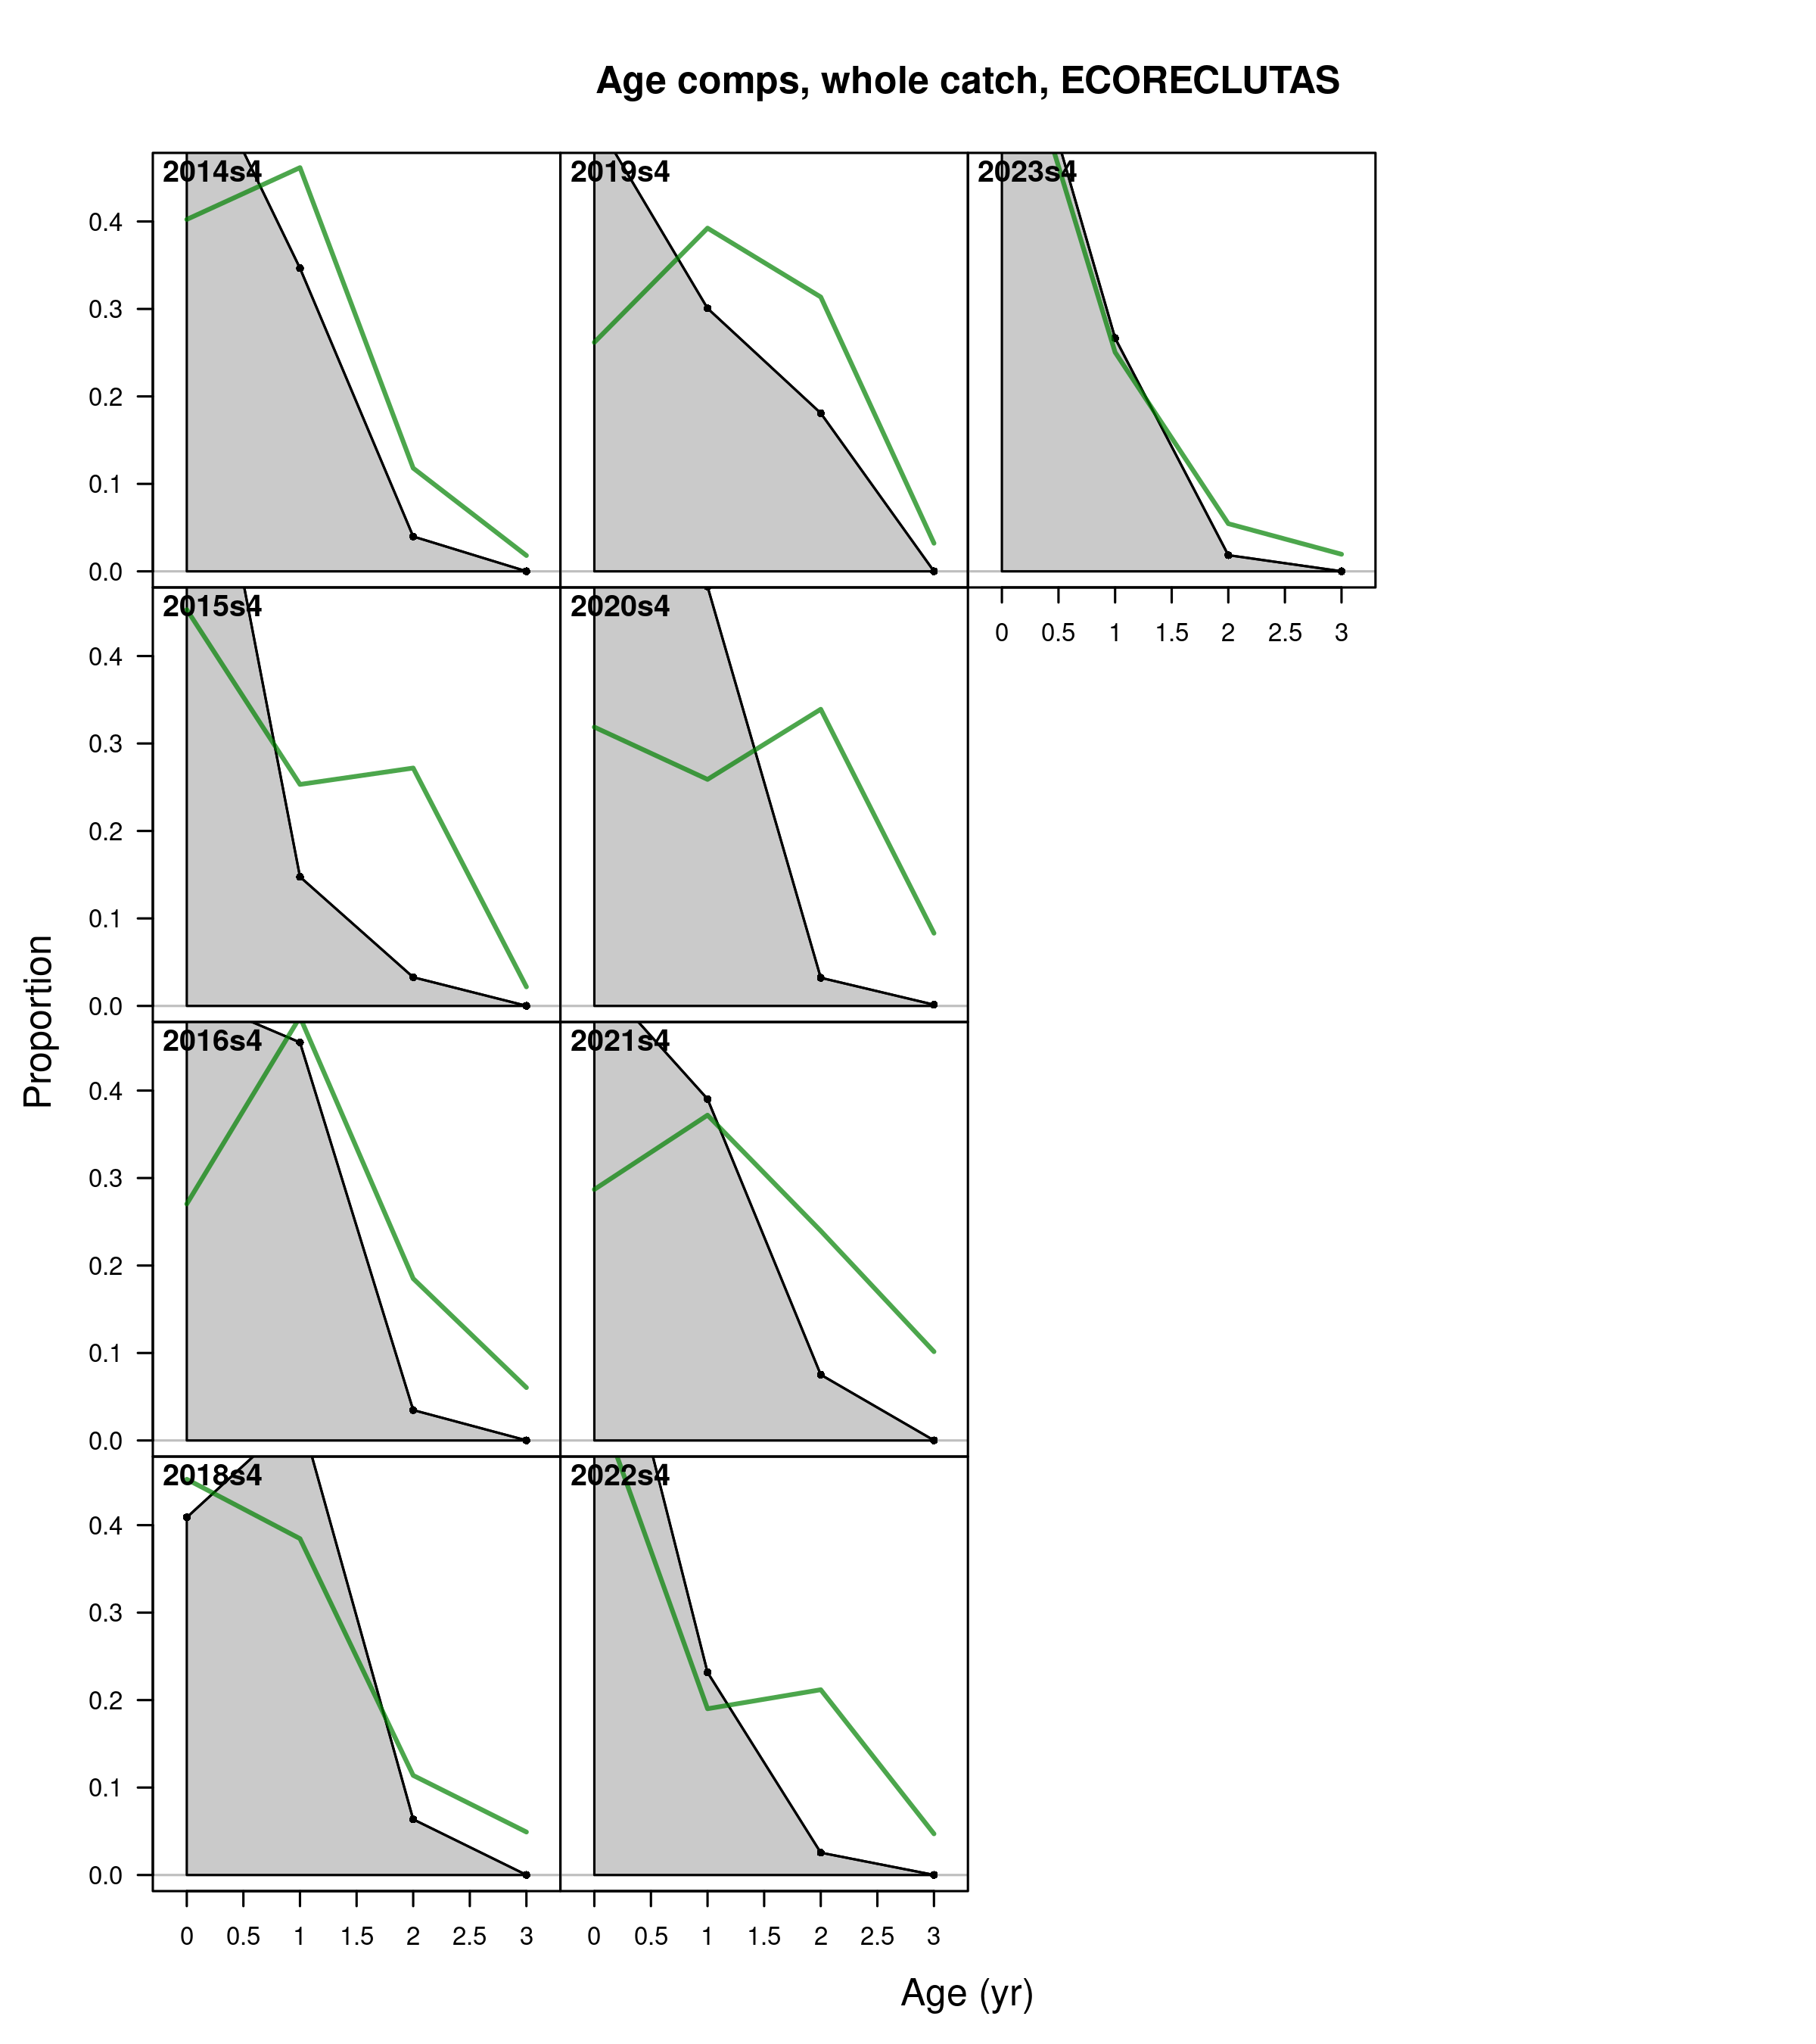

Figure .: Ane.27.9a stock. Model fit to the age composition data from the *ECOCADIZ-RECLUTAS* fall survey by year. The green line represents the model estimates, while the shaded gray area shows the observed data.

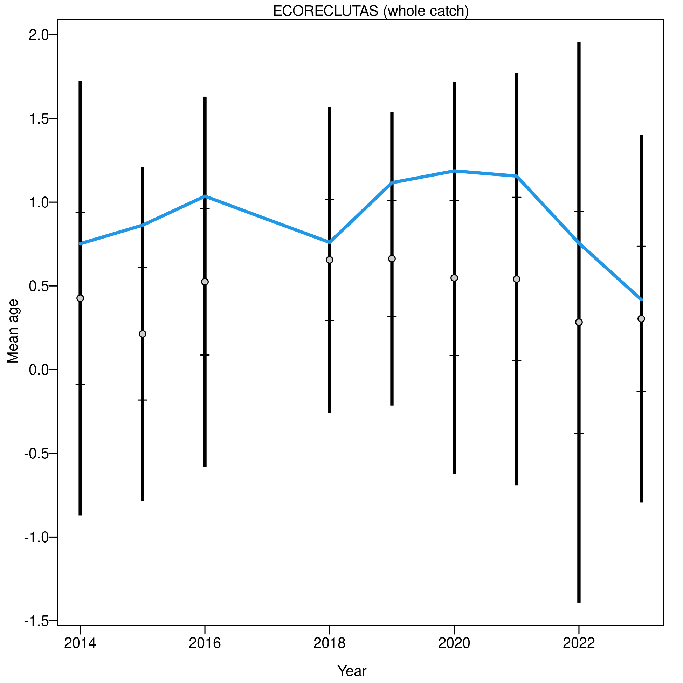

Figure .: Ane.27.9a stock. Mean age for *ECOCADIZ-RECLUTAS* with 95% confidence intervals based on current sample sizes. Francis data weighting method TA1.8: thinner intervals (with capped ends) show the result of further adjusting sample sizes based on the suggested multiplier (with 95% interval) for age data from *ECOCADIZ-RECLUTAS*. The blue line corresponds to the estimated mean age.

#### Age residuals

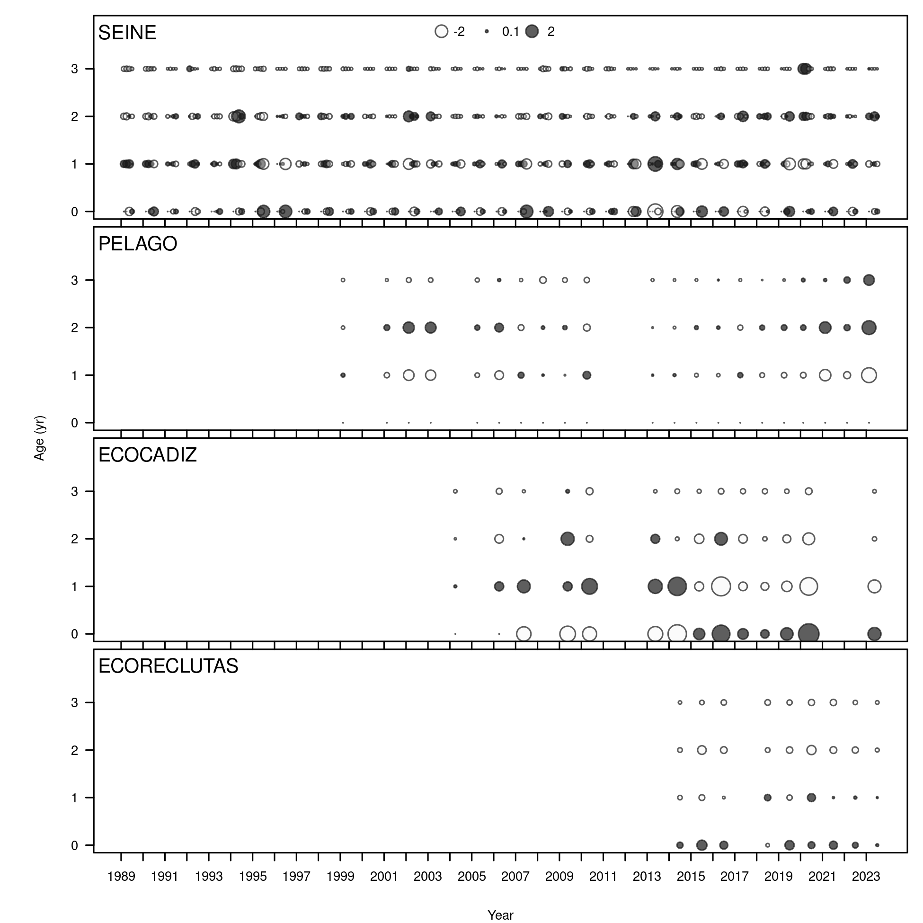

Figure .: Ane.27.9a stock. Pearson residuals, comparing across fleets. Closed bubbles are positive residuals (observed > expected) and open negative residuals (observed < expected).

#### Mean age residuals

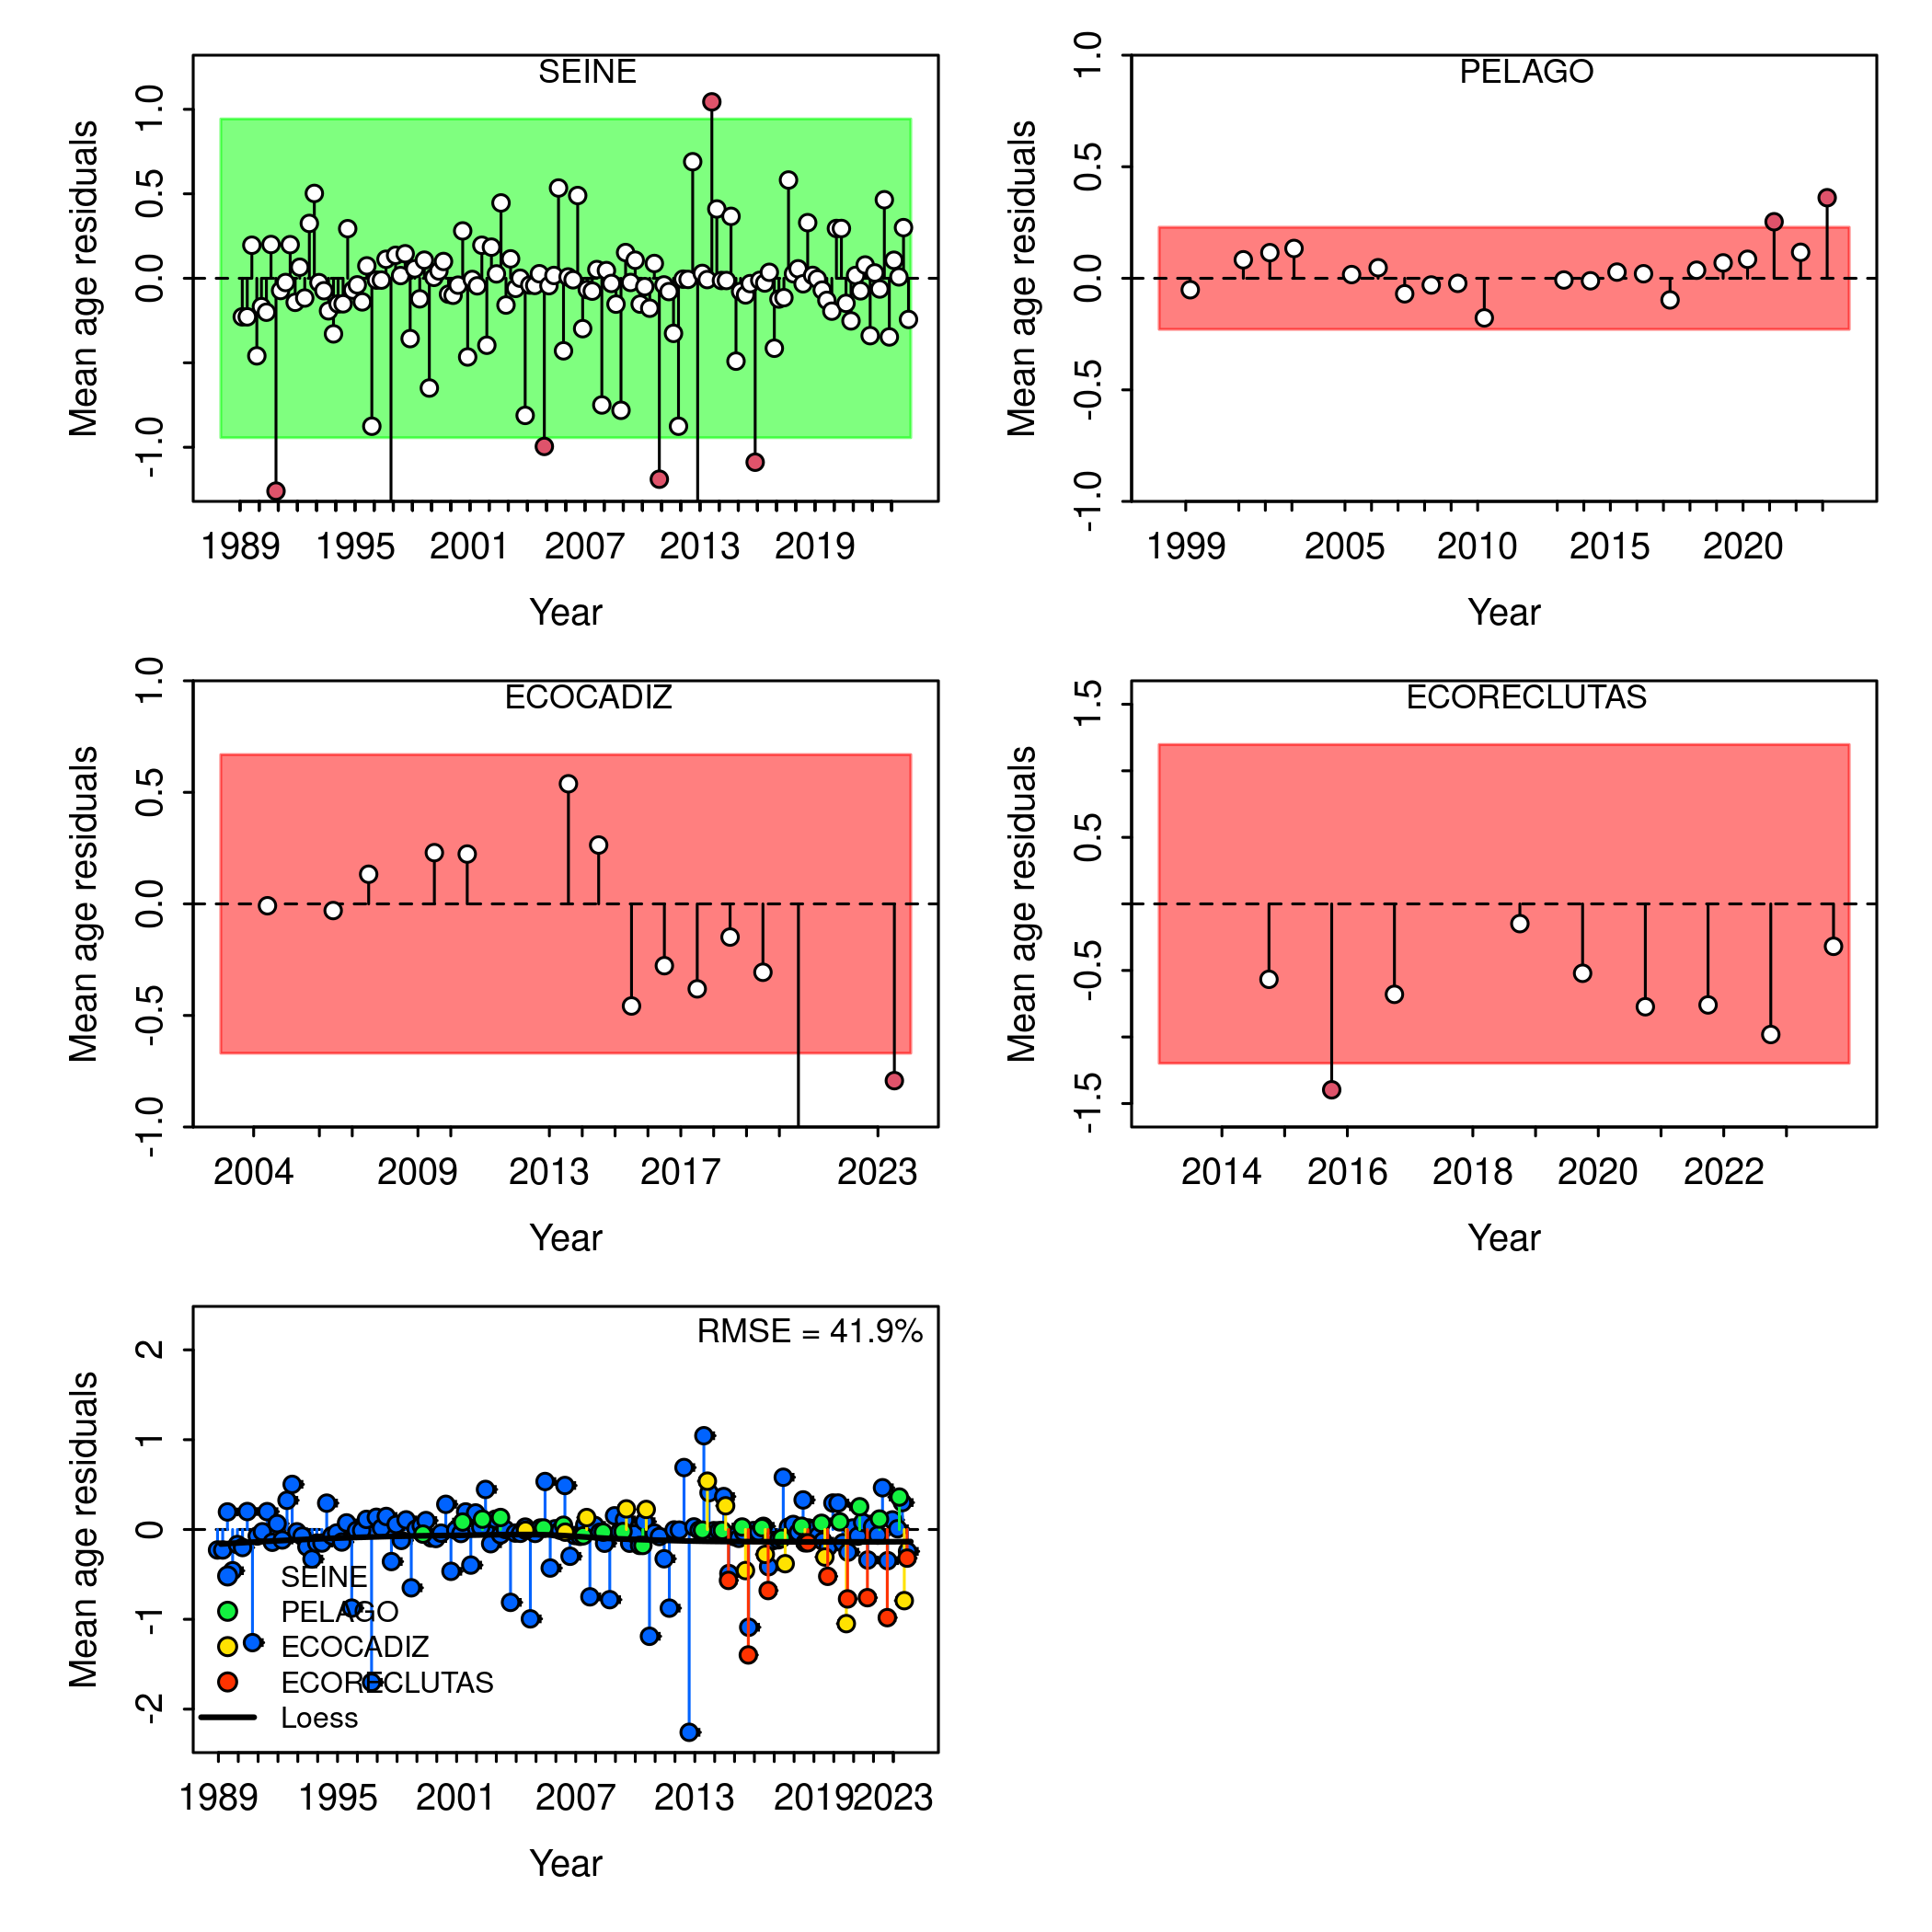

Figure .: Ane.27.9a stock. a) Runs test results for fits to annual mean age estimates for the surveys (*PELAGO*, *ECOCADIZ*, *ECOCADIZ-RECLUTAS*) and the fishery (*SEINE*). Green shaded (green/red) area spans three residual standard deviations to either side from zero, and the red points outside of the shading violate the ‘three-sigma limit’ for that series. The complete set of runs test results is presented in Table xx. b) Joint residual plots for annual mean length estimates for surveys and fishery. Vertical lines with points show the residuals, and solid black lines show loess smoother through all residuals. Boxplot indicate the median and quantiles in cases where residuals from the multiple indices are available for any given year. Root-mean squared errors (RMSE) are included in the upper right-hand corner of each plot.

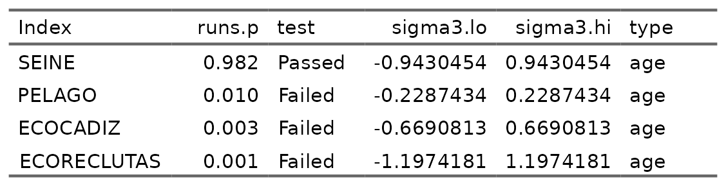

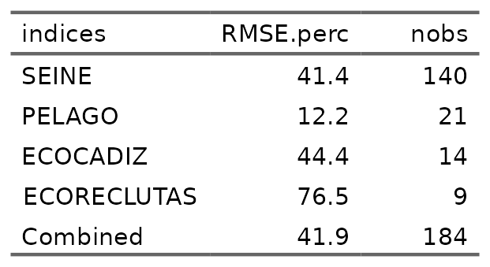

### Retrospective

Figure shows the retrospective pattern of spawning biomass and fishing mortality (F) for the base model. The retrospective analysis of the assessment model indicates that in terms of phi (mean of retrospective anomalies), the reduction of information generates a pattern of underestimation of fishing mortality (phi = 0.0614104) and a pattern of overestimation of spawning biomass (phi = -0.0240889). In general, the estimates of biomass and F for the most recent years can vary substantially between successive updates, while in the earlier years, they tend to converge to stable values. The model exhibits high statistical variance in the last years of the series, resulting in greater uncertainty for projections and generating unreliable estimates for establishing management measures.

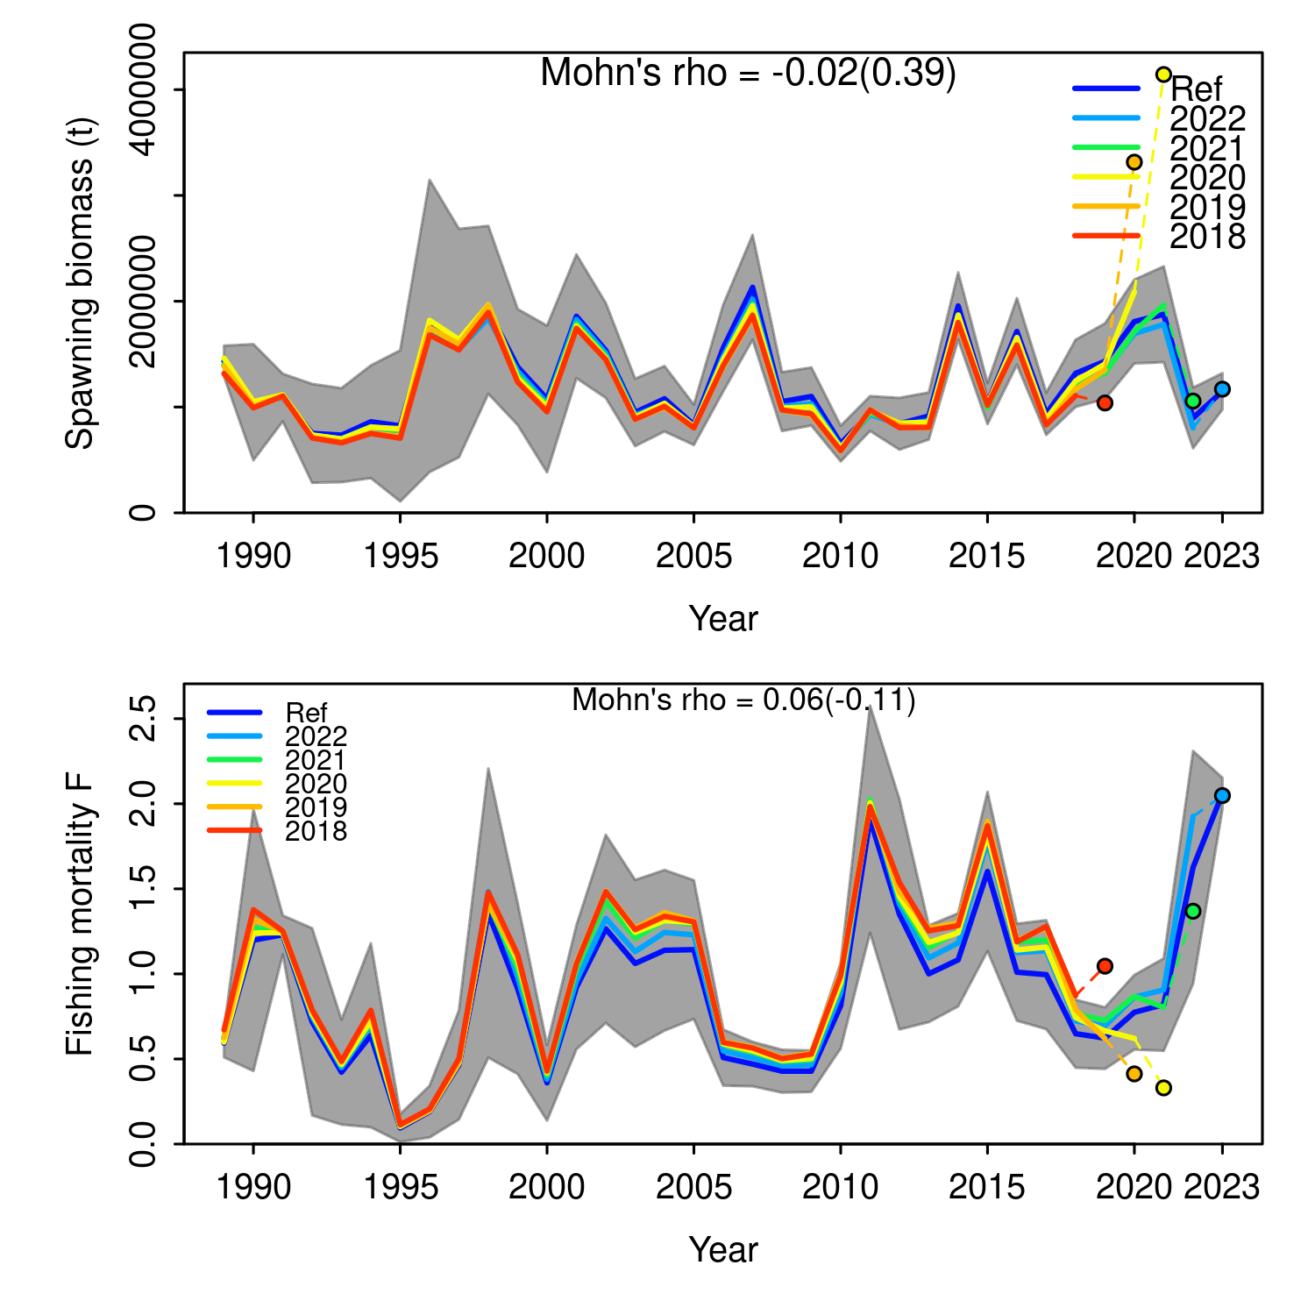

Figure .: Ane.27.9a stock. Retrospective analysis of spawning stock biomass (SSB) and fishing mortality (F). Models conducted by re-fitting the reference model (Ref) after removing five years of observations, one year at a time sequentially. The retrospective results are shown the entire time series. Mohn’s rho statistic and the corresponding ‘hindcast rho’ values (in brackets) are printed at the top of the panels. One-year-ahead projections denoted by color-coded dashed lines with terminal points are shown for each model. Gray shaded areas are the 95% confidence intervals from the reference model.

## References